T

social media in business

Oliver Collins-Cope

Richmond Upon Thames College

BTEC National Foundation Diploma IT

Table of Contents

Introduction 2

Different Social Media Sites 2

Facebook 2

Audience profile of Facebook 3

Facebook and Business 4

Twitter 17

Audience profile of Twitter 18

Twitter and Business 19

Instagram 30

Audience profile of Instagram 31

Instagram and Business 32

Pinterest 41

Audience profile of Pinterest 41

Pinterest and Business 42

YouTube 50

Audience profile of YouTube 50

YouTube and Business 51

Risks 59

Negative comments on social media sites and damage to reputation 59

Time constraints of social media interaction, return time on investment 60

Unforeseen consequences of posted content 60

Conclusion 61

Bibliography 62

# Introduction

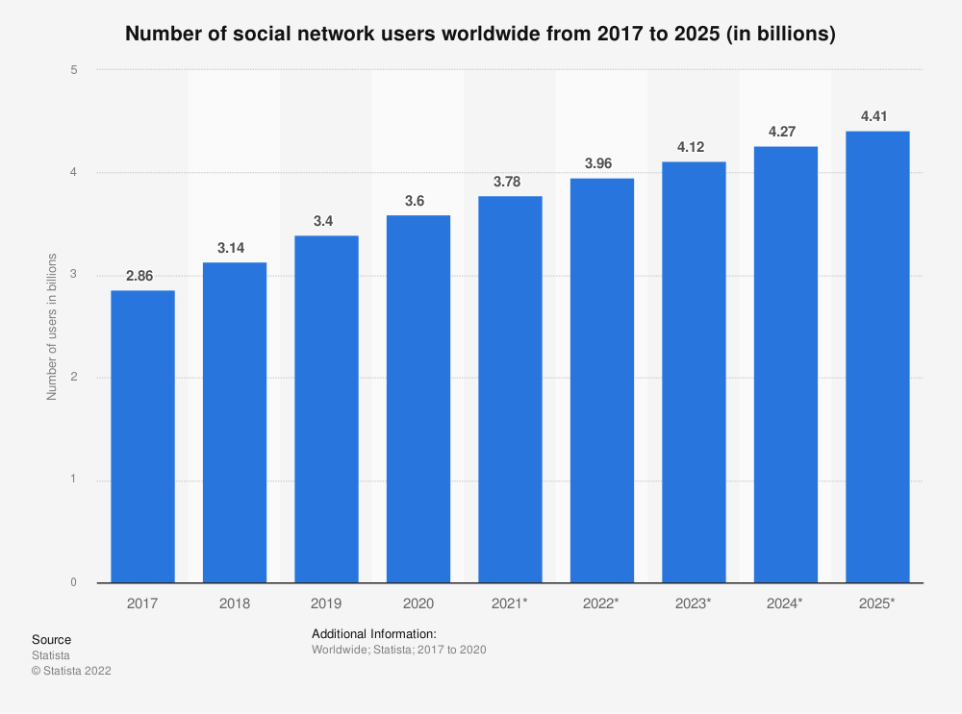The use and influence of business in social media is growing larger by the day, with more businesses investing in starting Social Media pages on different websites and applications, as the potential for growth and exposure comes at just the click of a button to post. With more people using social media applications and websites, with an estimated 3.78 billion users in 2021 (Statista Research Department, 2022), it is crucial for businesses to have an online presence, not only to advertise to customers, but in order to be au-fait with the current era and be able to provide a modern experience for the customer base, as well as provide adequate support where required using different features such as private messages, comment sections, and many more.

(Statista Research Department, 2022)

# Different Social Media Sites

## Facebook

Arguably the most famous and biggest social media giant out there, Facebook remains at the forefront of social media since it was founded in 2004. With around 2.9 billion active users in 2021 (DataReportal, 2021) (Iqbal, 2022) Facebook remains to be the largest social media site in use, beating YouTube in second place by around 600 million active users in 2021 (Statista Research Department, 2022) proving Facebooks status as a necessity for any business to grow and expand.

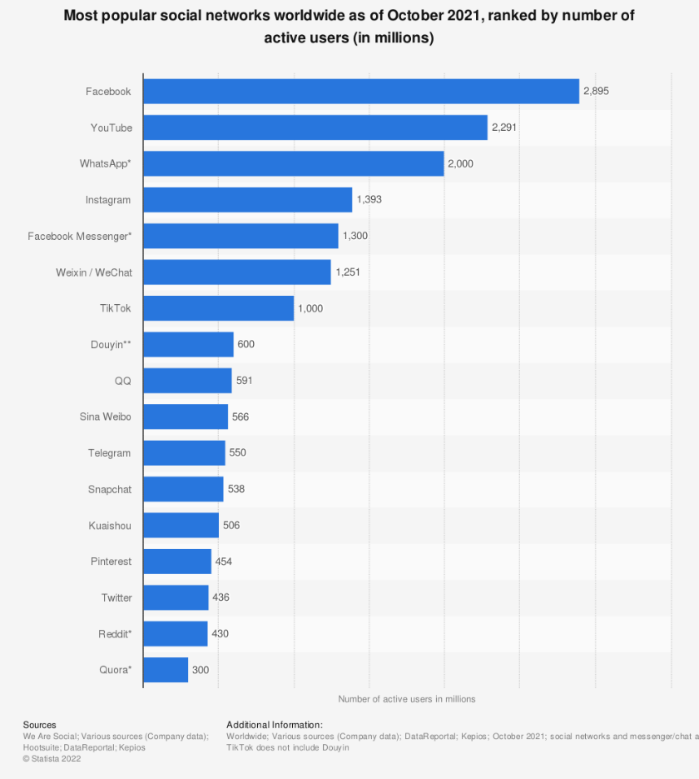

(Statista Research Department, 2022)

### Audience profile of Facebook

The largest demographic group of Facebook users is between around 25-35 years of age (Aslam, 2022). Around 56% of Facebooks user base is male, with the remaining 44% identifying as female, as Facebook does not allow users to select nonbinary gender types (Aslam, 2022). This could potentially be a feature Facebook hopes to explore in the future.

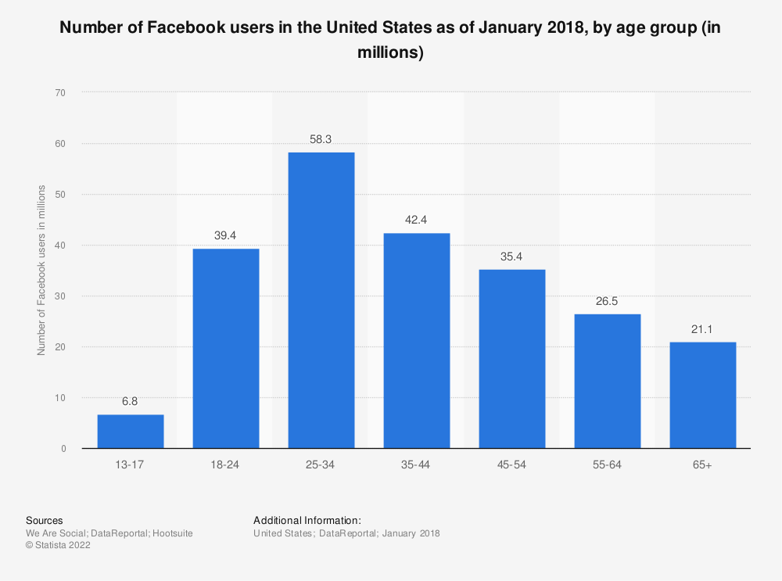

(Statista Research Department, 2022)

Within the largest age demographic of 25-35 years of age, 19% of all active male users are within this age group, and 12.5% of all females are within this age group, which are the highest percentage of any given gender in any age group, and makes up the majority of users as of October 2021 (Statista Research Department, 2022).

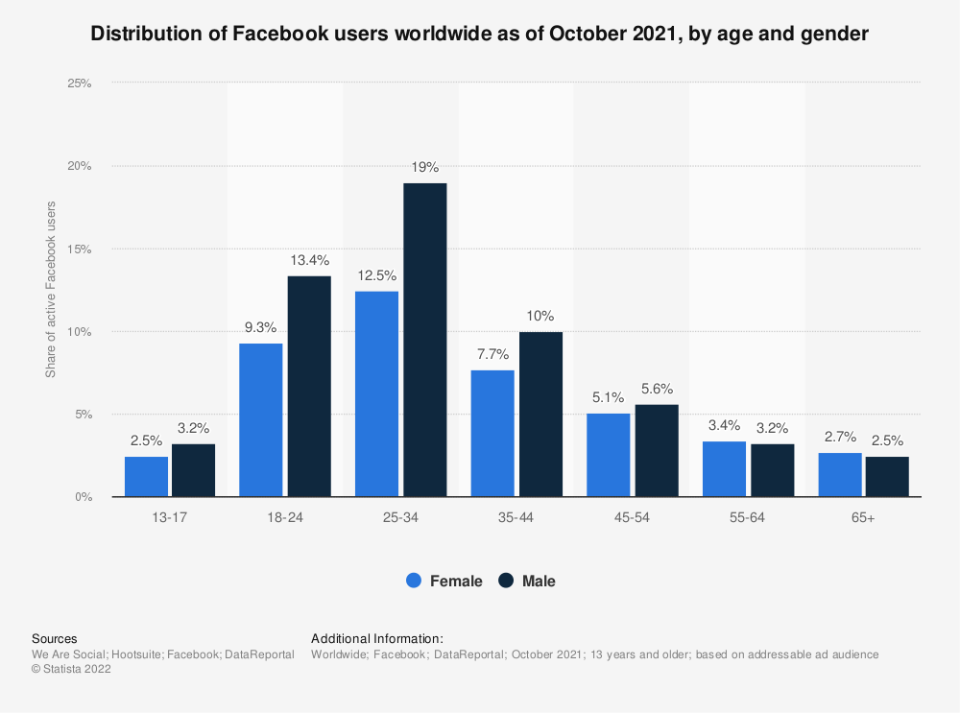  
The next largest demographic of Facebook would be the 18-24 range. Males in this age group make up roughly 13% of all Facebook users, while females make up around 9% of Facebook users (Statista Research Department, 2022).

### Facebook and Business

There are a few features available to businesses on Facebook, which are not limited to just those available to a standard user. The primary features Facebook has to offer to businesses comes from the “Facebook Page” feature, which allows a user, or business in this scenario, to create a page for a specific thing, such as the business in question, and post on behalf of the business. In addition to adding a presence on the website, it also allows users to discover the business just through searching through a search engine and finding a social media for it on business or searching through Facebook and discovering through that.

The features included with “Facebook Page” includes:

* Calls-to-Action
* Post Scheduling
* Profanity Filters
* Page Moderation
* Scheduling events
* Pages to watch/Up to date comparison
* When your page users are most active
* Statistics for post types
* Exporting page insights
* Target audience selection
* Creating Adverts
* Page Customisation (Aesthetic)

(Urrutia, 2015) (Howen, 2015)

(Quadros, 2021)

This is an example of a call to action, which incites customers to click on the button, which is beneficial to one’s business, and leads to another link when the button is clicked on.

An example of a call to action would be this –

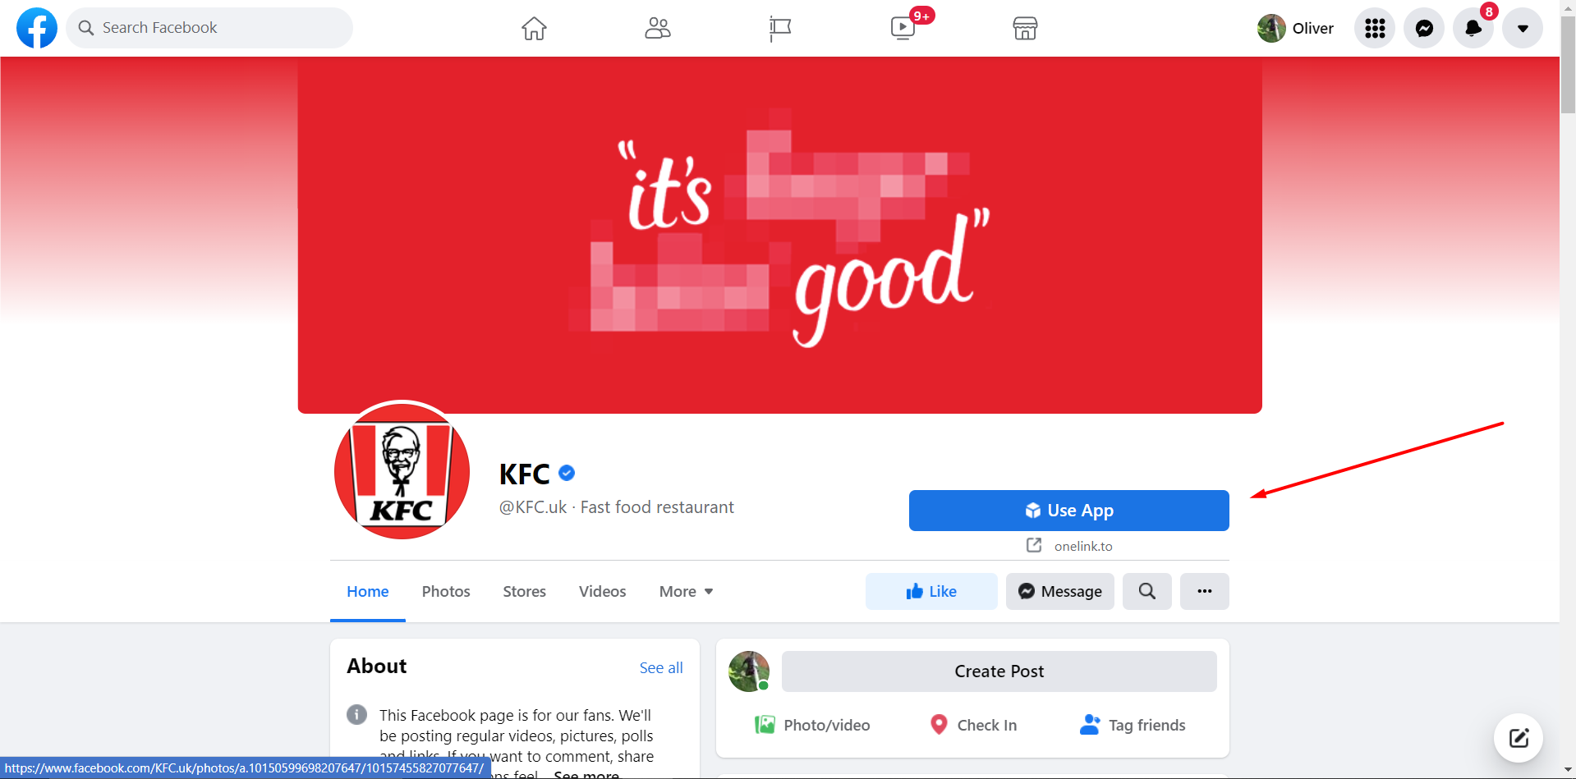The use app button which links the user to another website which allows users to order KFC to their house.

A call to action can be used by a business to provide users with different options related to the business, such as ordering food, or following the page in question.  
In this example, the “Use App” call to action is effective as it promotes the businesses product and pushes mobile integration onto the user with a preinstalled application.

#### Post scheduling/Scheduling events

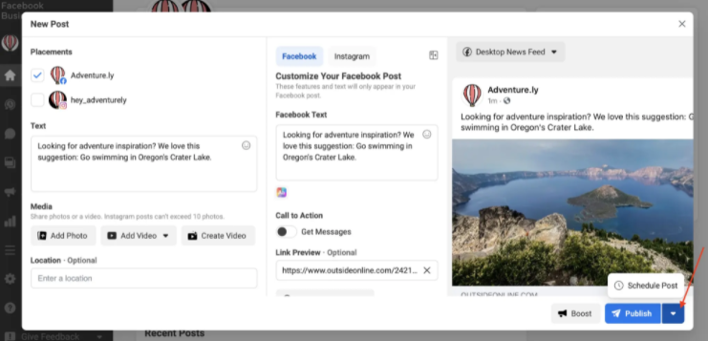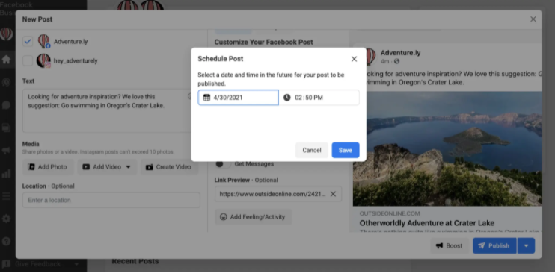

(Olafson, 2021)

As seen above, the post scheduling feature is self-explanatory, allowing users to post at specifically predetermined times in order to space out content or post when otherwise would not be possible.  
Scheduling events works the same way, only through the events section of the page and creation options.

Post scheduling is an effective tool for businesses as it allows them to post when it might otherwise not be possible, such as in the middle of night when everyone is asleep, or when the people running the page are unable to post due to a variety of reasons, like holiday or outages.

#### Profanity filters

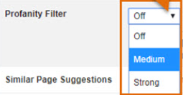

(Shuffield, 2019)

As depicted in the picture, Facebook offers a profanity filter which means that depending on the level of strength chosen, certain profanities might be allowed, whereas when strong is chosen, all will be filtered out and messages containing profanities will be deleted or will have to be moderator approved.

This is crucial for businesses as it decreases the risk of having a presence of social media which could negatively impact the business if users are posting profanities or being disrespectful/offensive.

(Urrutia, 2022)

As seen, page moderation allows users to blacklist specific words or phrases, such as slurs or swears, which would be damaging to the business if seen on the page.

In addition to this, it can also be used to keep content irrelevant to the business out of the page and therefore increase relevant activity towards the business.

In conjunction with profanity filters, this is crucial as it prevents users from posting harmful content or words which could negatively impact a business, and therefore reduce the risk of being on social media.

#### Pages to watch/Up to date comparison

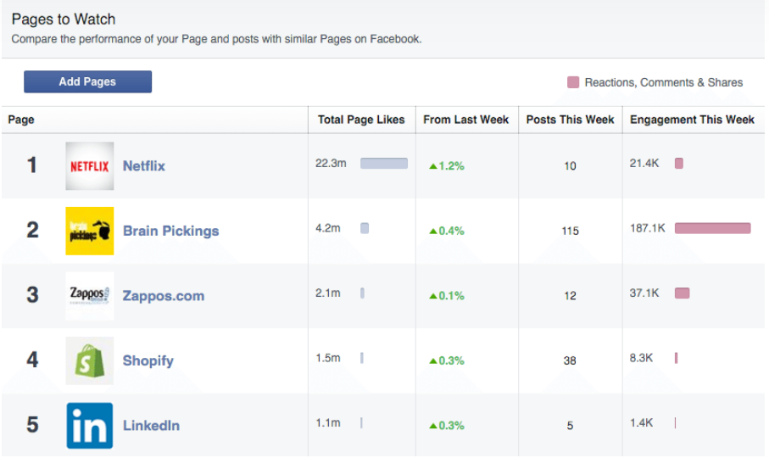

(Kolowich, 2021)

Through the pages to watch section, users and businesses can find how much interaction different pages have been having, including their own and other similar businesses, and therefore track different competitors and compare what was doing well and what was negatively influencing other competitors

Pages to watch/Up to date comparison is a useful tool for businesses as it allows them to adjust their page when necessary and ensure they stay at the top. This is because businesses will be able to look at what different factors of their page have and therefore make changes to improve it.

#### When your page users are most active

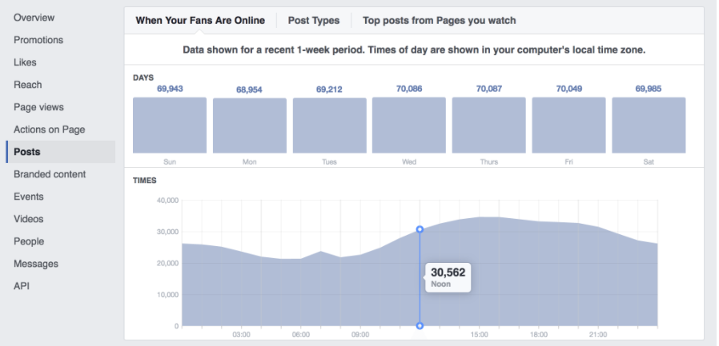

(Facebook, 2022)

This feature allows businesses to check when users are most active on the page and therefore post at times that have highest activity, leading to a higher interaction rate.

This coincides with “Post scheduling” as through this business will be able to set up posts to post at times there is a high user activity, and increase the chances of a higher viewing of the post.

#### Statistic for post types

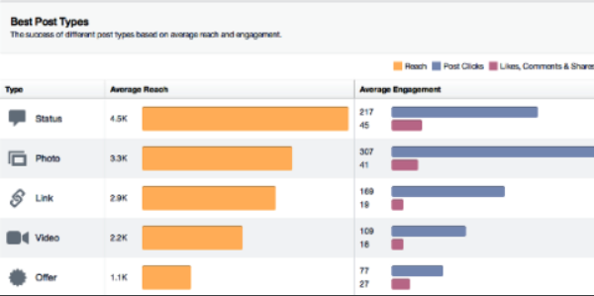

Facebook allows users to check what types of posts receive different levels of engagement and their average interactivity for the different types of posts, and therefore post the content that works best with different users.

An example of what types of posts leading businesses use in the last few years is show below.

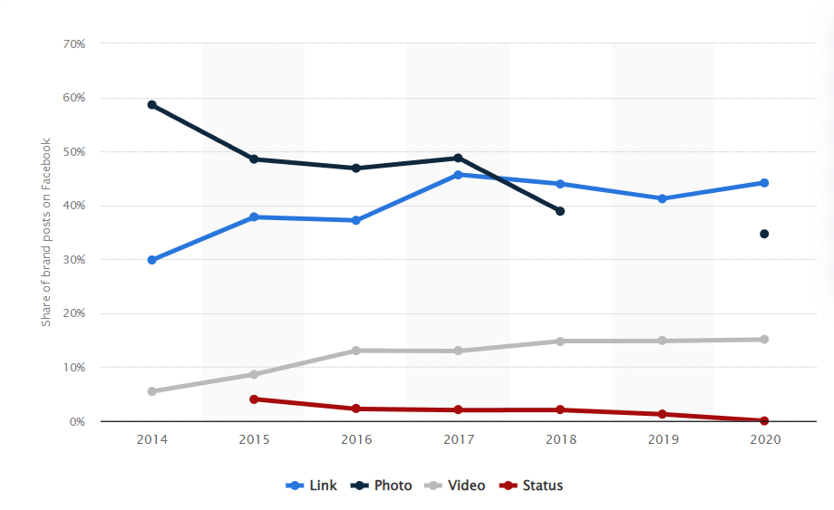

(Statista Research Department, 2022)

Through this we can tell that photo content has decreased over the last few years on Facebook, and content involving videos and links has increased since 2014.

This allows business to post the content that viewers on their page interact with the most and therefore allows them increase the chance a user will interact with the page, potentially leading to sales or promotion.

#### Exporting page insights

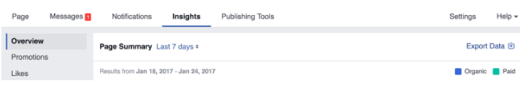 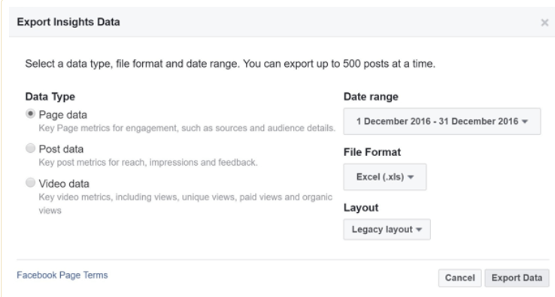

This gives the user to export any data from the designated date range about the page insights into a spreadsheet or whatever file format they prefer, in order to be able to analyse the data about the spreadsheet.

This allows businesses to analyse their page insights more intricately and is important for businesses in order to ensure that the content and media they post is of a high standard which coincides with the media their page users enjoy consuming.

#### Targeting audience selection

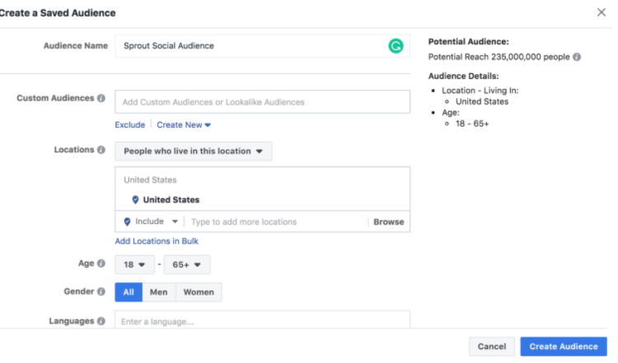

The screenshot above shows how Facebook allows users to create specific audiences in order to target the customers and consumers whom they think will be more likely to purchase their product, such as maybe those who are 18-25, or male as opposed to male and female. This also includes setting up languages like only targeting English speakers with a specific audience profile.

This is useful for businesses as it allows them to target specific audiences for their product which may be critical in some situations, such as beauty products for those over 50, or game products which could be targeted for a specific country and younger age group.

#### Creating adverts

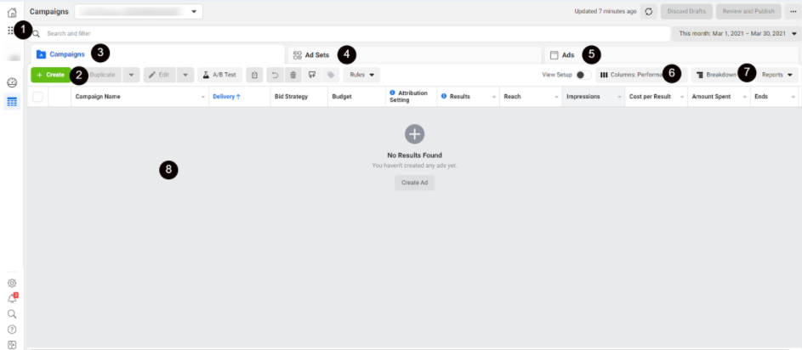

The Facebook business manager allows you to create adverts and select specific advert objectives. It is important to note that this is not free, and businesses have to set aside a budget for their Ad campaigns.

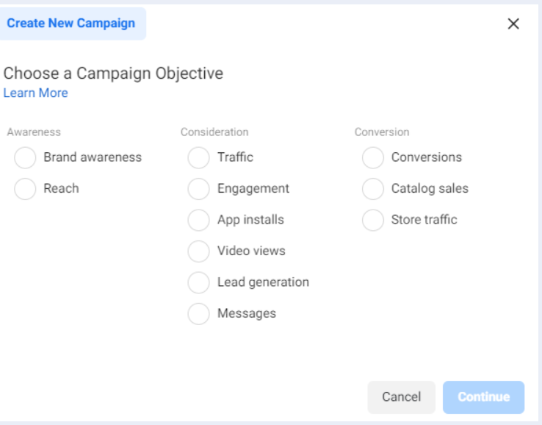

Using this, businesses can create Facebook Ads that are managed by Facebook and promoted automatically or manually, depending on what the user decides.

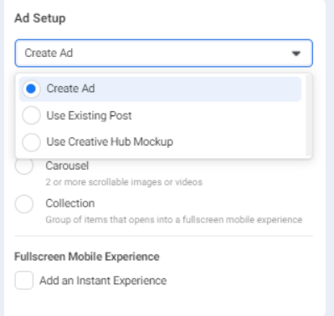

Then the user creates an Ad using the campaign they created, or make a new one, and publish it.

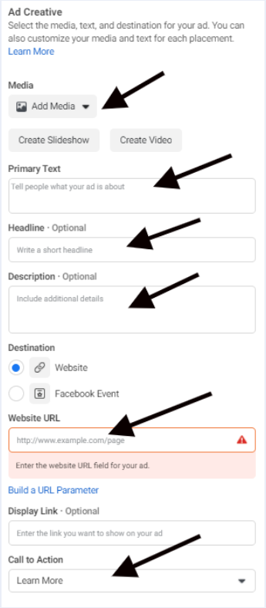

These advertisements are important for businesses as it allows them to promote their page and create more of a presence online in order to grow.

An example of an advert on Facebook –

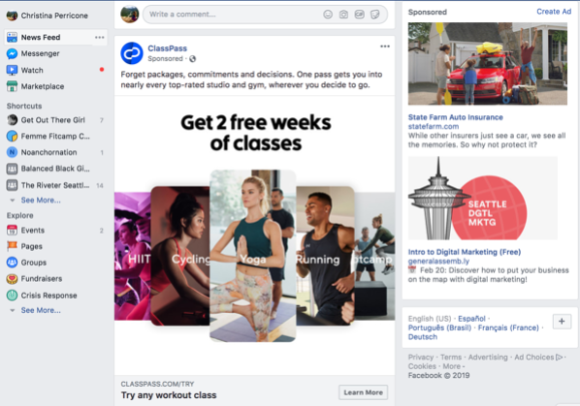

In this example, the “ClassPass” business is advertising 2 free weeks of classes. This is an effective advertisement as it clearly puts in the image something to grab the user’s attention, and then allows the business to go into more detail in the description of the post.

#### Page customisation

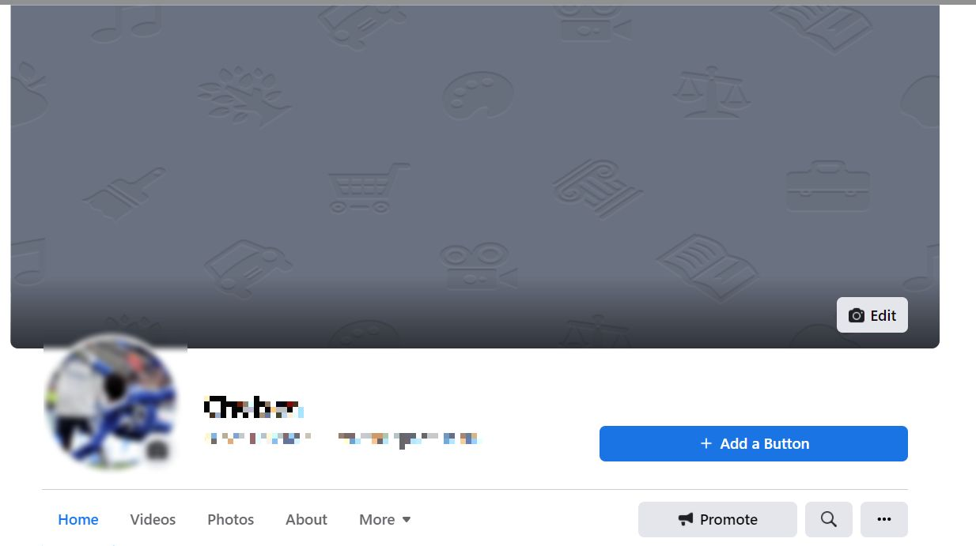

This refers to things such as a custom page banner on the background, and custom profile picture, allowing the business to make the page about them and personalise it as needed for the page to be fit for the business.

Included in this is the about subsection of the page, with the following details available to be edited.

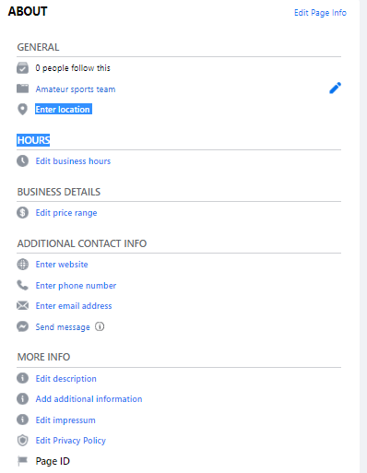

An example of this in Facebook KFC –

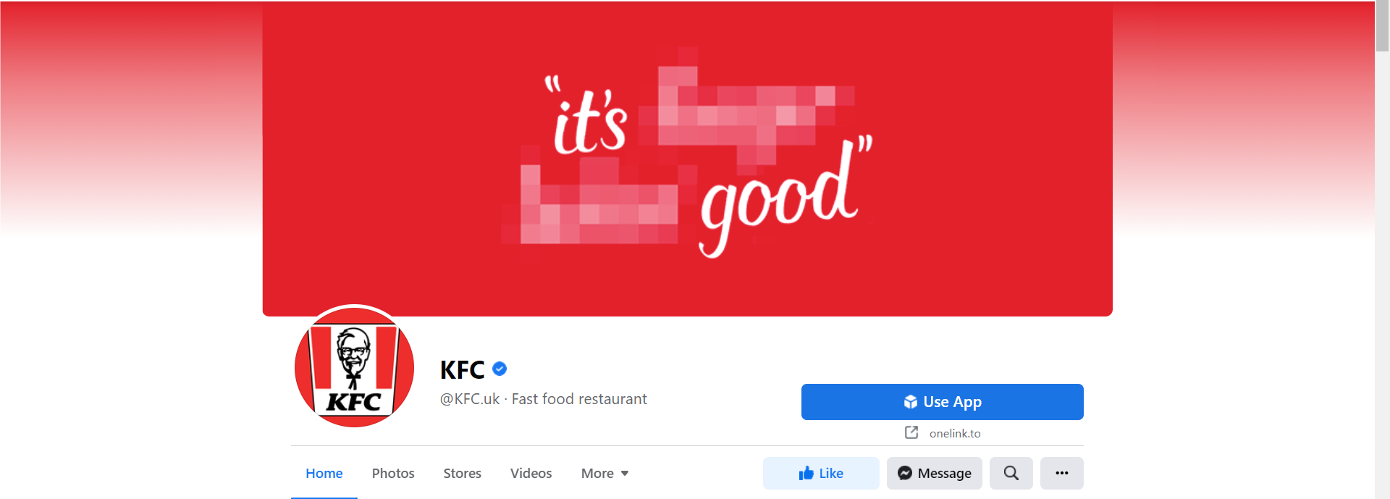

Page customisation is important for a business as it allows a business to create a brand image, or change their brand image into an existing one, and therefore align it with the businesses interests.

This is an effective use of this, as everything from the cover image, to the profile picture and name is highly customised to be around “KFC” and promotes this brand image.

## Twitter

Twitter is another social media that is important to consider as it is another one of the most popular forms of social media, with user numbers reaching 430 million in 2021. Twitters key characteristics lie in the fact that users/businesses are limited with the number of characters they can use to post, specifically 240. This means that any posts made on Twitter are concise and to the point, as users do not have the freedom to make long and complicated posts without making a long thread of posts. This kind of simple and fast content is on the rise in modern media, with applications like TikTok basing their entire app on short videos.



(Statista Research Department, 2022)

### Audience profile of Twitter

The largest age demographic within Twitter is between 25-34 years old with 38.5% of the total users being within this age bracket as of 2021.

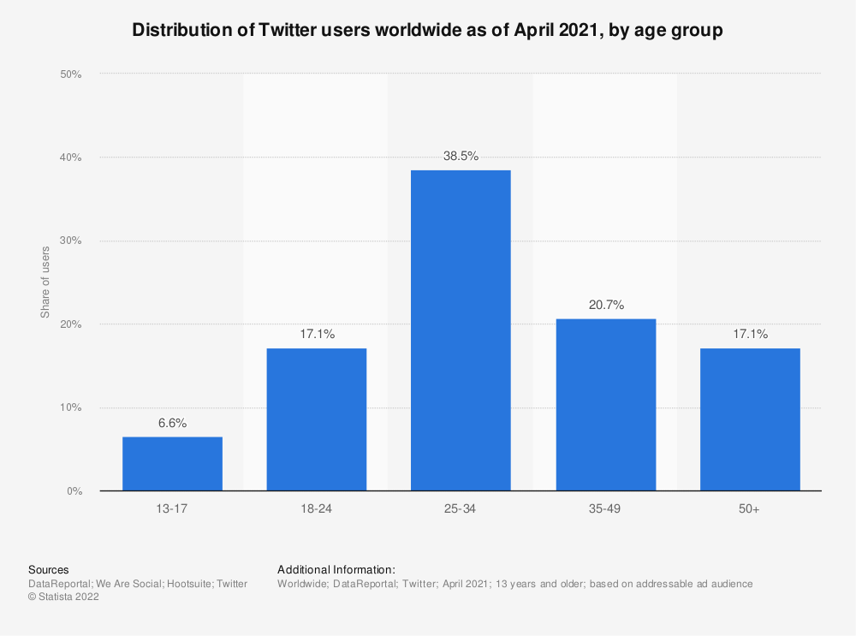

(Statista Research Department, 2022)

Within this, 70.4% of all Twitter users are male, meaning that the male population of Twitter has a significantly larger population compared to women, who only 29.6% of the population. When it comes to the US however, this number is slightly different, with men only having 61.6% of the total user base of Twitter, and women having 38.4% of the remaining users.

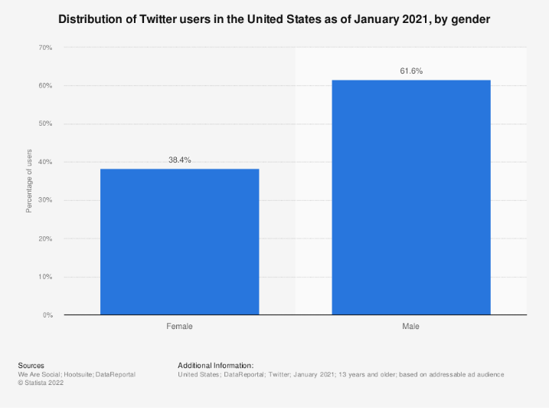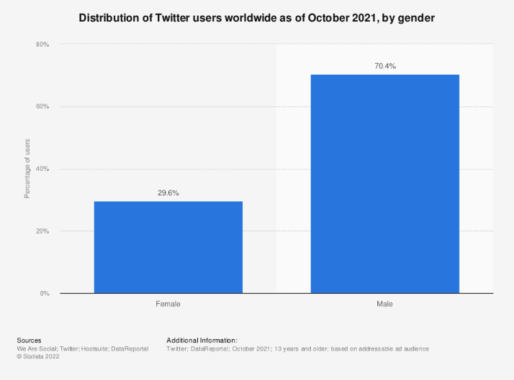

(Statista Research Department, 2022)

It is also important to note that Twitter provides options for non-conforming gender designations.

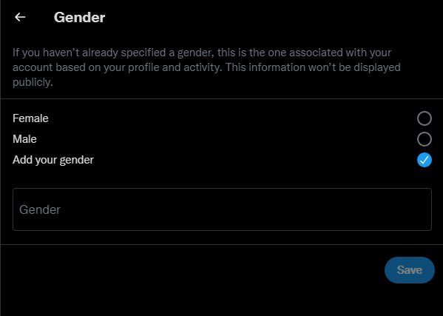

This means that those who use Twitter for business will focus primarily on advertising to late 20’s to early 30’s with their products, along with more focus on the higher population of male users on twitter, which may lead to a divide and gap between the amount of focus on one gender compared to the other.

### Twitter and Business

Twitters unique characteristic of only being able to post 240 characters means that businesses must be concise with their posts and straight to the point. This could potentially be a big advantage to businesses and users when it comes to direct advertising, as it may encourage users more directly to buy their product. Another benefit of the character limit is that it encourages companies/users to post videos and images rather than just text posts, which have a higher interactivity rate amongst users.

Other features of business in Twitter include:

* Twitter for Professionals
* Twitter Ads
* Analytics
* Hashtags
* Live “What’s happening”
* Direct messages
* Customer interactions
* Pinned tweet
* Customisations
* Retweeting
* Media
* Likes
* Call to action
* Scheduled posts
* Word filters

#### Twitter for Professionals

Twitter for Professionals is a feature that allows businesses and users to create professional accounts dedicated to running a business and providing the necessary content to promote and uphold that business. This allows for a clearly defined presence on the platform, which is separate from the original user.

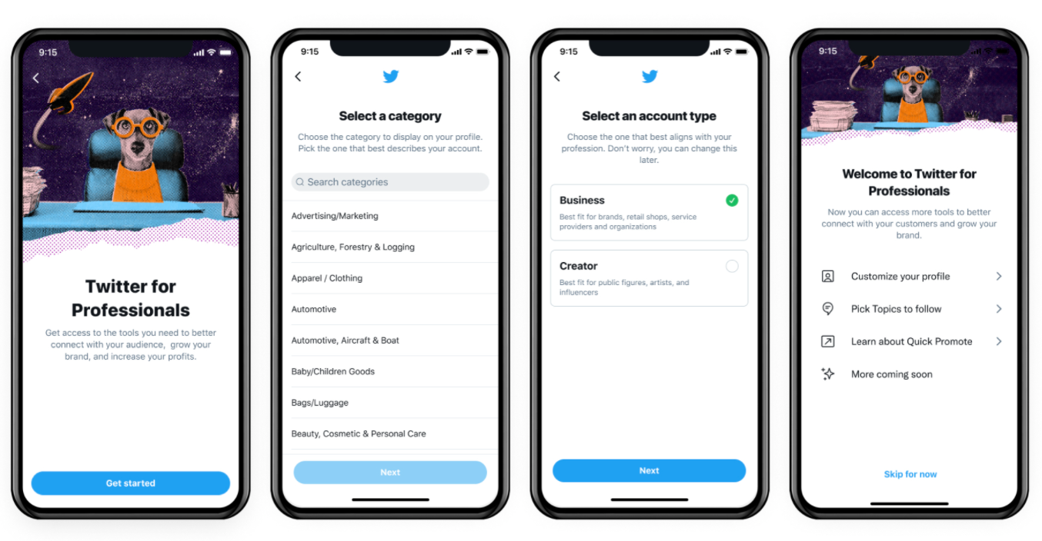

An example of a professional Twitter account could be KFC again, but on Twitter as opposed to Facebook this time.

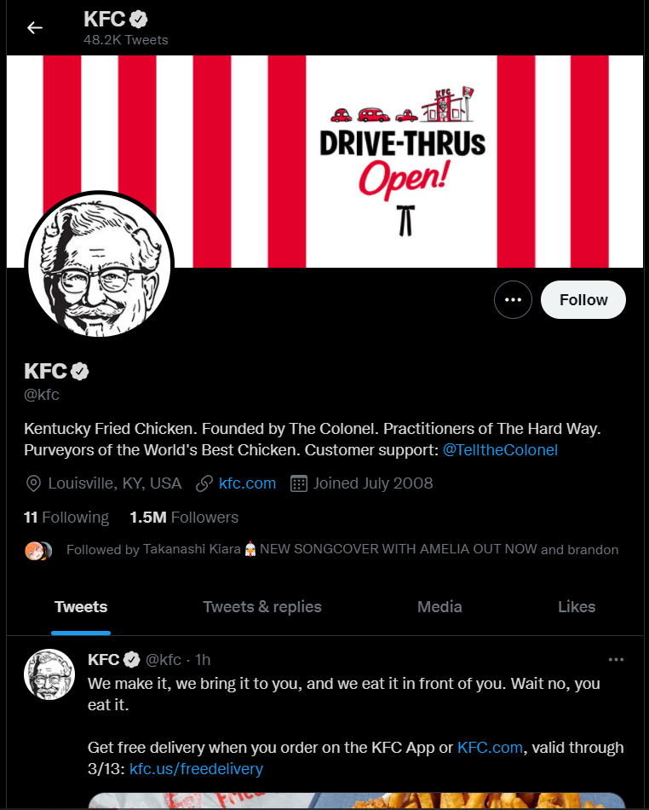

This feature allows businesses to create Twitter accounts specifically for their business and therefore this helps to establish them on the platform and separate them from general users.

This is a good example of a professional account as everything around the account is based around the brand, and optimise this account fully.

#### Twitter Ads

Twitter Ads refers specifically to a section of Twitter where a user or business can create an Ad.

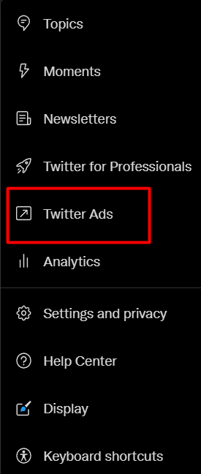

Twitter Ads allows you to create different kind of advertisements for specific countries and time zones/currencies.

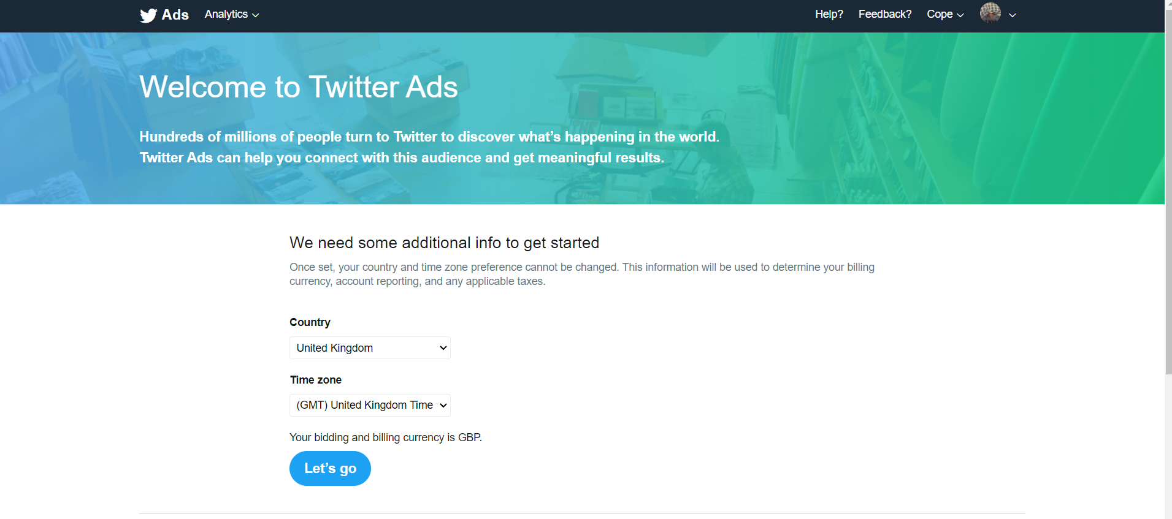

From here, users are given the option to choose their adverts objective, from awareness, to consideration, and finally conversion.

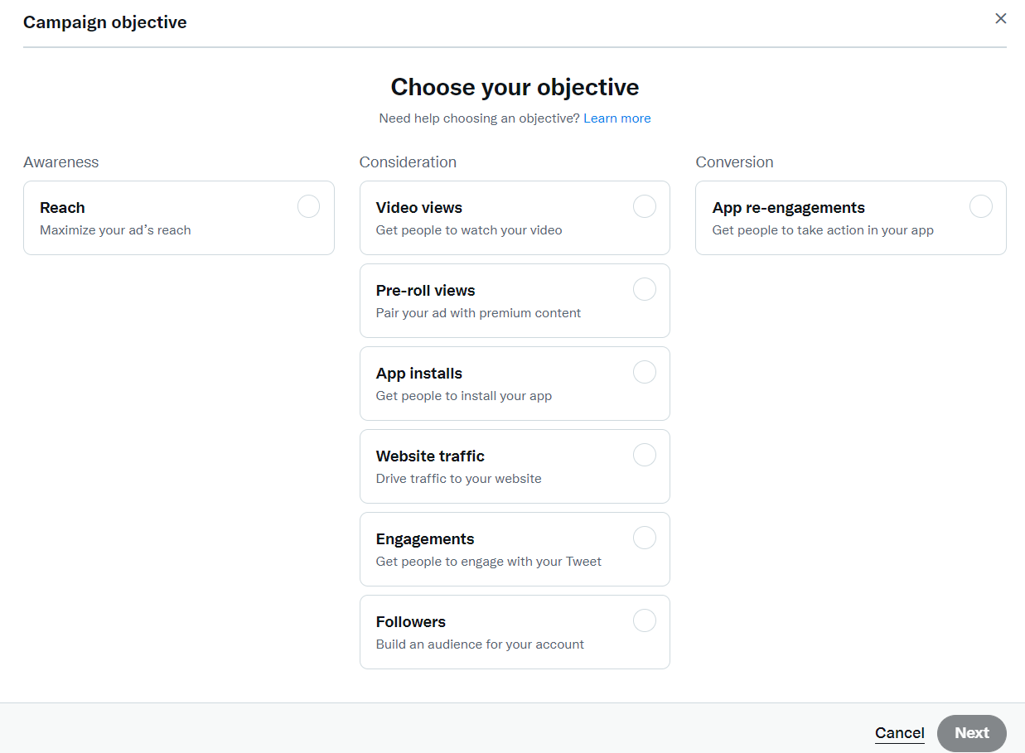

As shown below, users are then able to decide more specific details about their Ad.

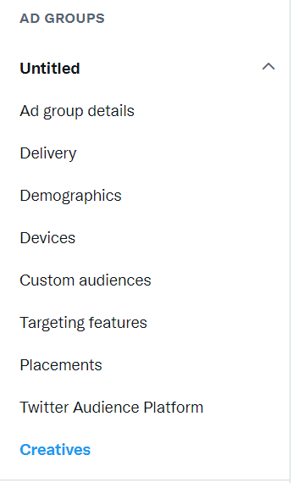

This has the same principle as Facebook Ads, just for Twitter.

#### Analytics

Analytics refers to a specific part of the site where the business for a summary analysis of their page.

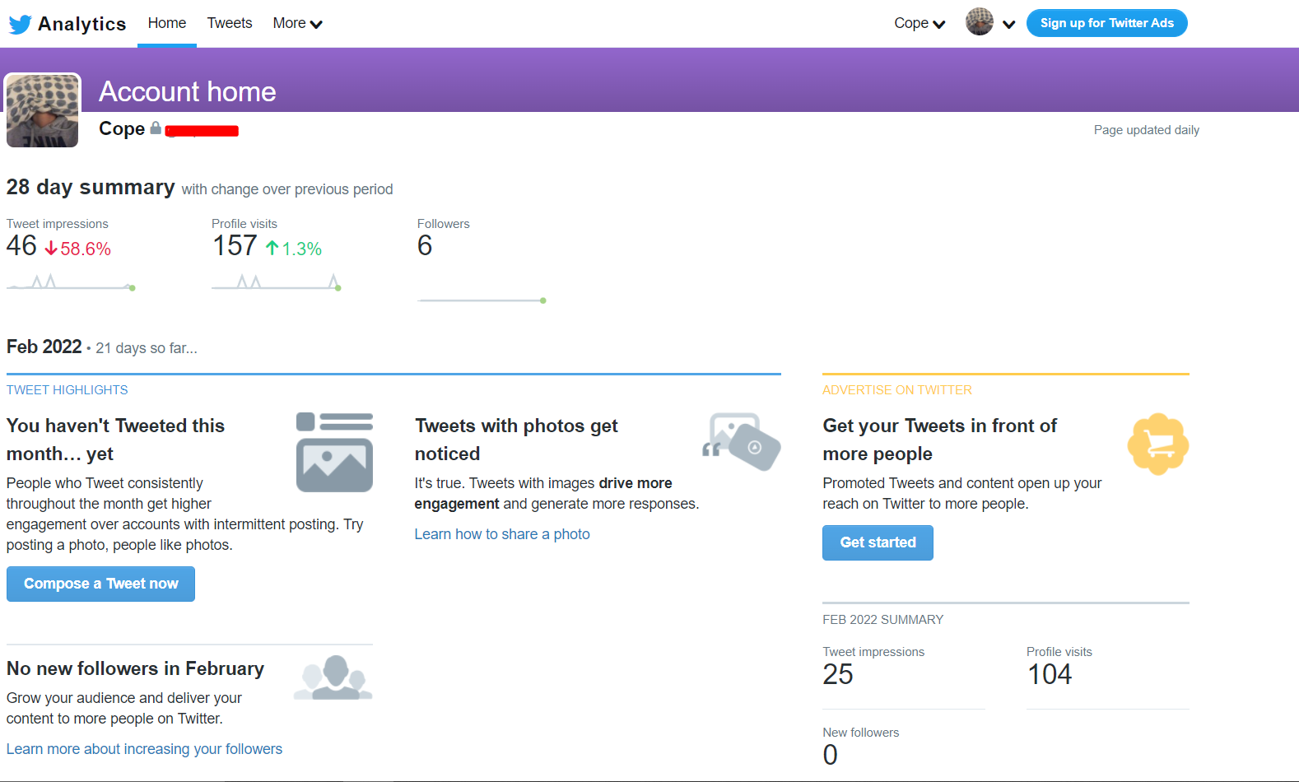

This allows businesses to view their “tweet impressions” which means how many times a user saw your tweets. Profile visits refers to how many times users clicked on and viewed the businesses profile, and “followers” allows businesses to check how many followers they have either lost or gained overall.

It also shows the best tweet a business put out, and best images/video an account put out.

This is important for a business as it allows them to view what of their content is doing well and what is harming their business. Through this, the business can adjust as necessary and improve on their page.

This is the same as Facebook post statistics, just for Twitter

#### Hashtags

Hashtags are a key part of Twitter, as they allow businesses to create topics and context for their tweets. Any hashtags that are clicked on by users will show any other posts made using the same hashtag, whether made by the original tweeter or not, and therefore allows for users to create threads under the same hashtag. In addition to this, popularly used hashtags often become “trending topics” and are promoted on general users Twitter.

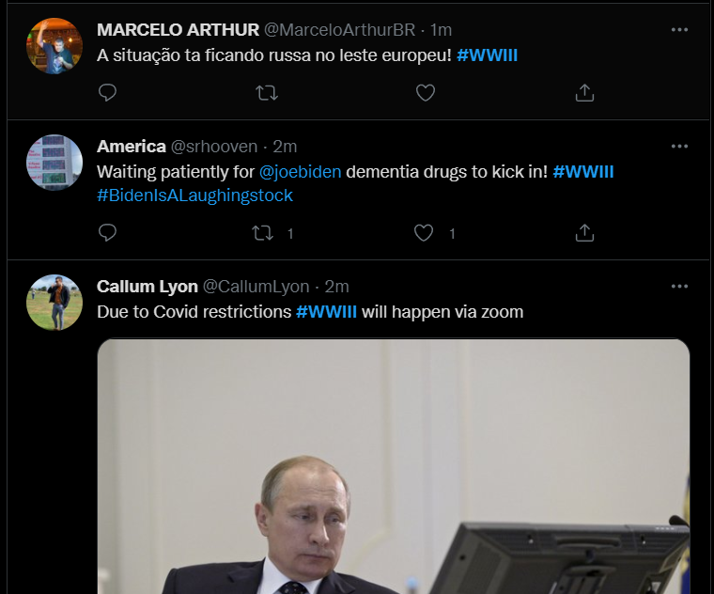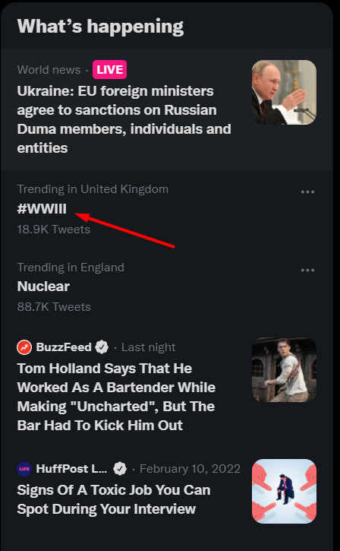

Hashtags can be used by businesses in order to become “trending” and therefore appear on different user’s home feed on Twitter, promoting their business and gaining more attention.

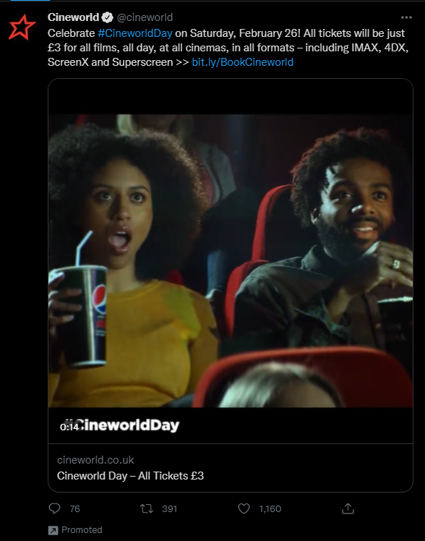

This example shows how a business has promoted themselves to the trending page, and is an effective use of hashtags.

#### Live “What’s happening”

This refers to the “What’s happening” part of the page, which coincides with “hashtags”.

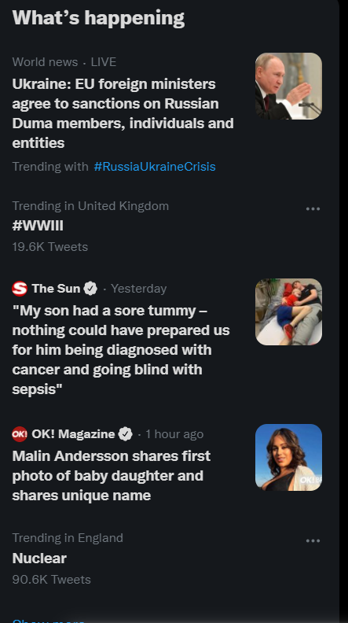 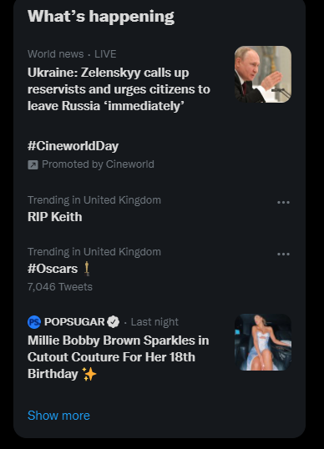

A business can use this to promote their page by showing up on the “What’s happening” and therefore expand their reach to new users.

#### Direct messages

Direct messages allow businesses to directly and privately message individual users.

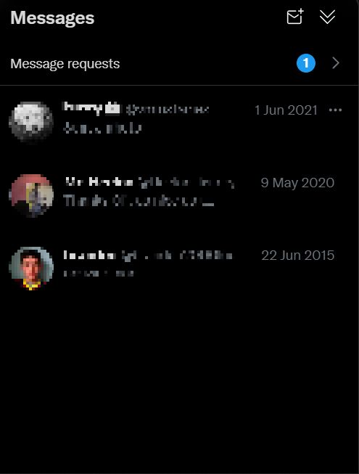

This can be very helpful for businesses when users have issues or complaints which need to be dealt with quickly, and is effective for resolving issues.

#### Customer interactions

This simply means that Twitter accounts and businesses interact with customers on their page, rather than simply direct messaging them, in order to either help resolve issues or just respond to their tweet.

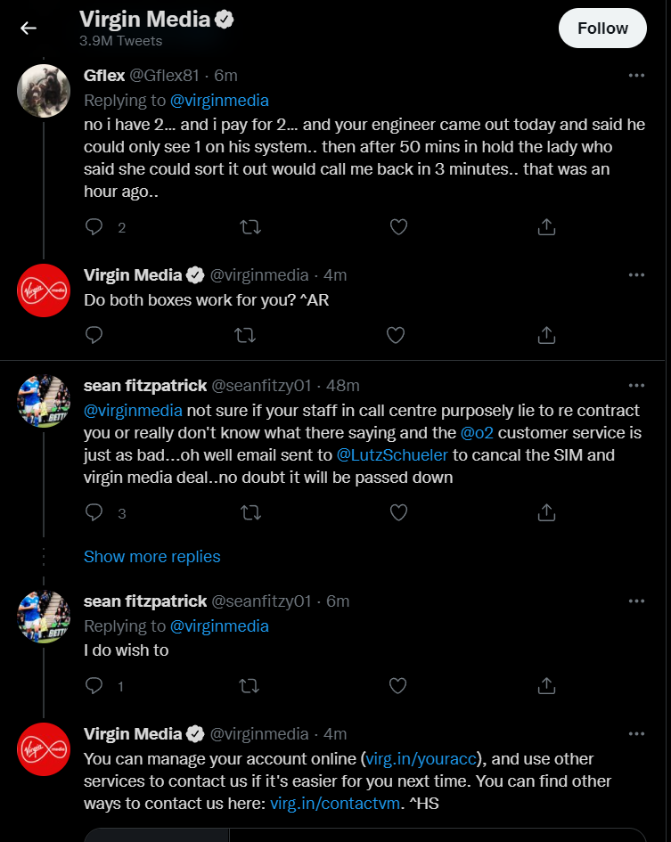

These customer interactions allow users to view how the businesses interact with customers, which can be helpful for a business to promote a positive business image to their consumers.

This is a good example of customer interactions as it shows that the business interacts with its customers and not just with standard copy/paste responses, but taking time to respond and resolve any issues.

#### Pinned tweet

Pinned tweets are tweets that are open as soon as the user clicks on the Twitter account, no matter how long ago it was tweeted.

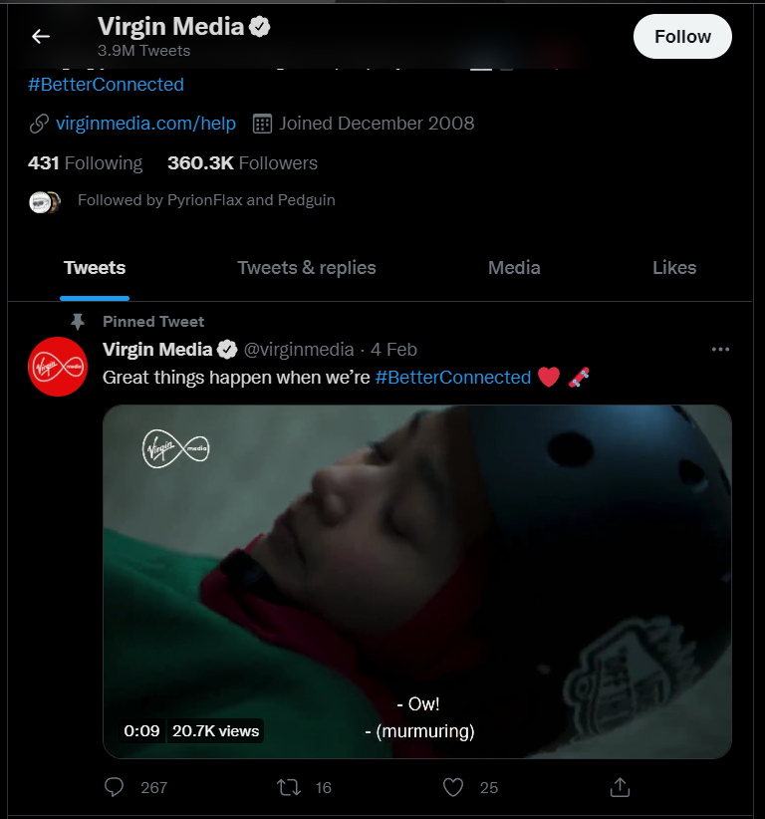

Pinned tweets allows businesses to break up their feed/posted content and promote a tweet that they find important to their business.  
This example is effective as the pinned tweet includes a video which is easy to view and get distracted by, increasing user interaction with the page. This also includes a use of a hashtag, which helps to separate what the tweet is about.

#### Customisations

This allows businesses and users to customise their Twitter account, from their header to the profile picture, or the biography and link.

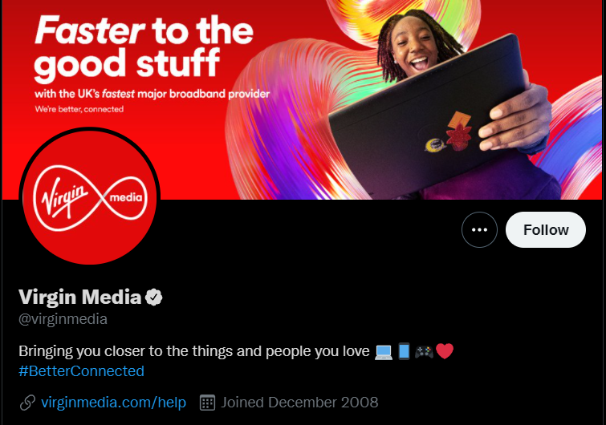

As seen above with Facebook, this is the same only for Twitter.

#### Retweeting

Retweeting allows Twitter accounts to share tweets their want to through their page, with the message that it was retweeted, essentially allowing them to “retweet” that tweet.

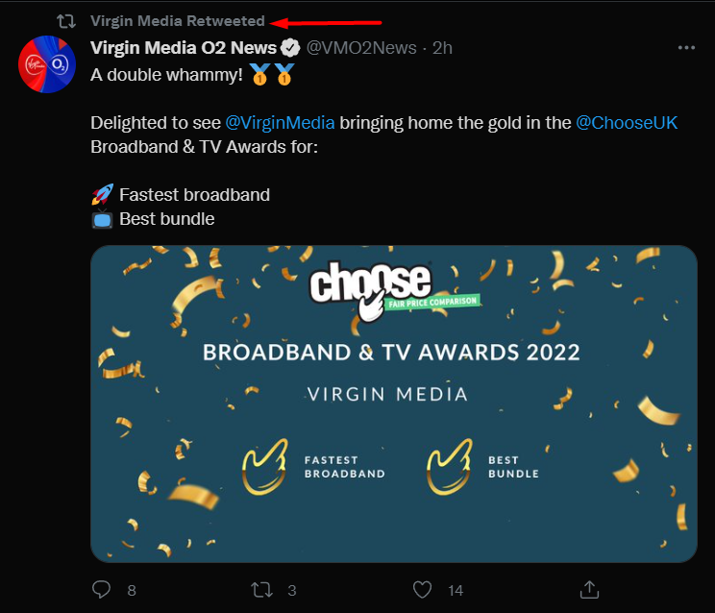

This is beneficial for a business as it allows them to promote content that they agree with, or that would help their business, and helps to boost their brand image.  
This is an effective use of retweeting as the business has retweeted another account related to the business, which promotes content related to the business and is with less risk as it is a verified account of “Virgin Media”

#### Media

Media is one of the sections on a Twitter accounts page where users can view an accounts different post that involve media, such as videos or images.

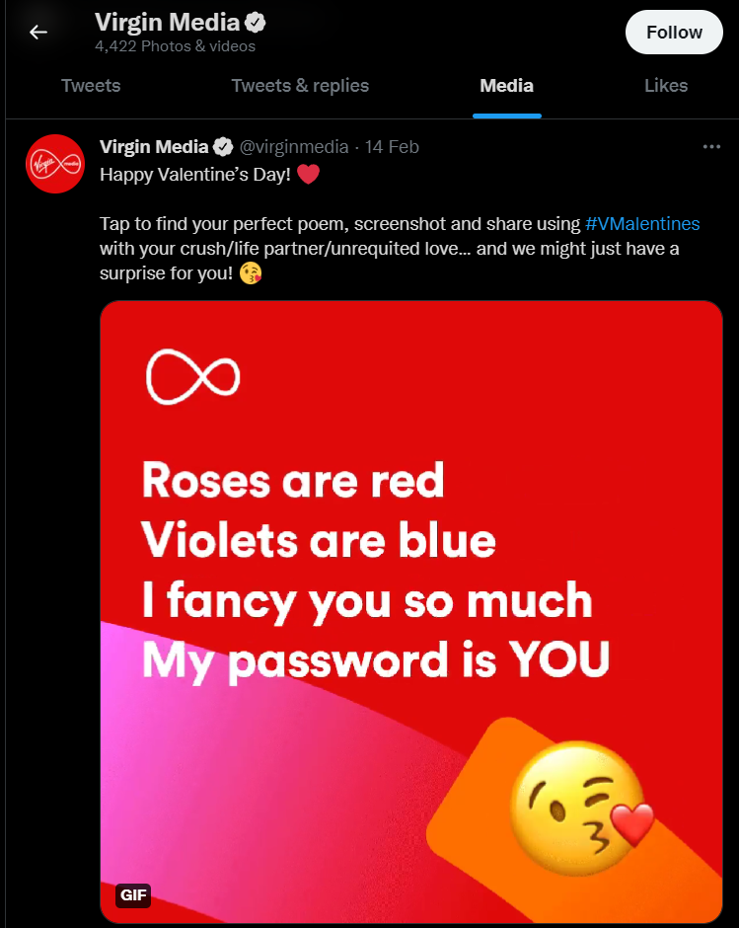

The media section is beneficial for the business as it helps users to find content from the account that has “media” in it, like images or videos.

#### Likes

Likes is similar to media, except it involves the tweets that the account “likes” and allows users to view this.

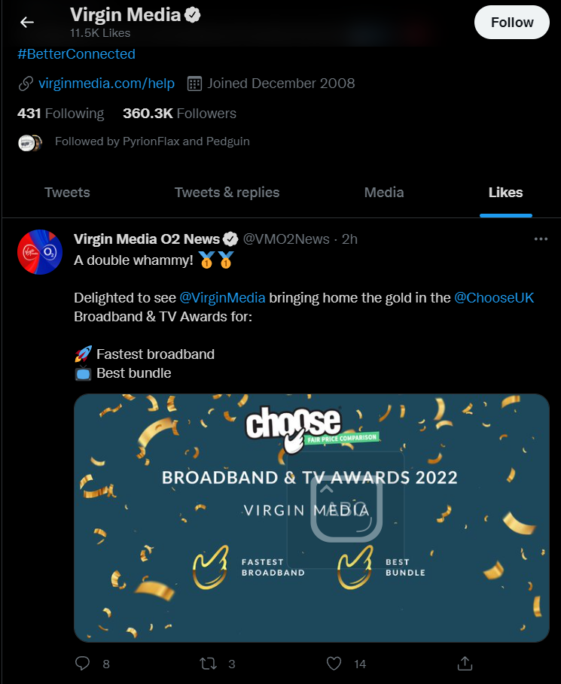

Just like the retweeting section, this allows businesses to promote content they agree with by liking it such as posts about the business or promotions for the business.  
As seen above, this is the same tweet that was liked by the same account, and helps to promote the “TV Awards”, which is an effective use of the likes section.

#### Call to action

As seen above, this is similar to Facebook.

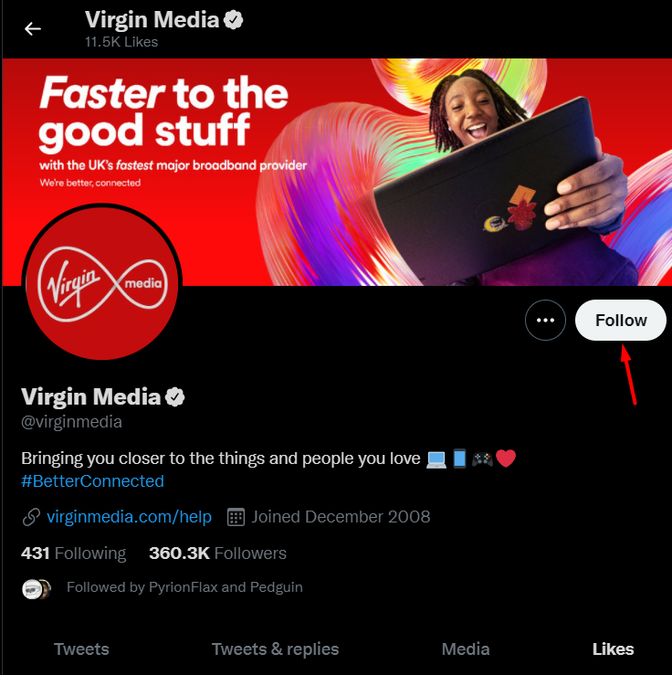

#### Scheduled posts

As seen for Facebook, this allows accounts to schedule when they make posts.

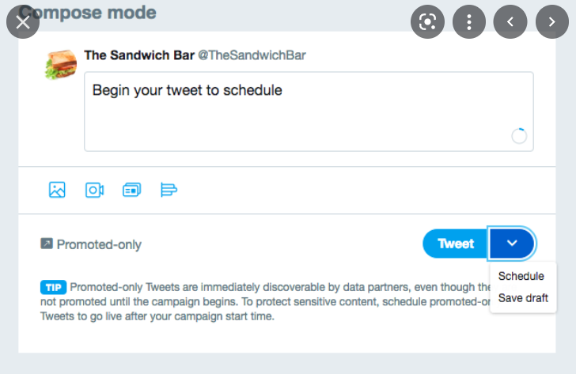

#### Word filters

Similar to page moderation for Facebook, this allows accounts to block prechosen words, such as swears or slurs.

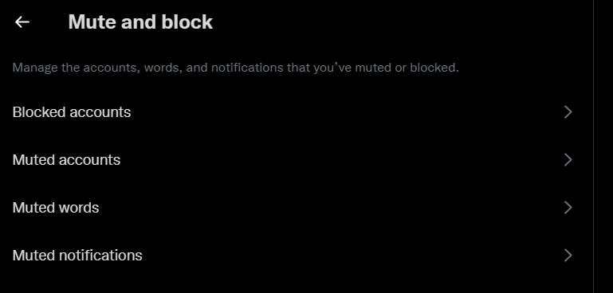

## Instagram

The third form of social media I will be speaking about is Instagram. Instagram is an application which is primarily used on a mobile device and has roughly 1.4 billion users as of October 2021 (Statista Research Department, 2022). While Instagram is primarily used on mobile devices, that does not mean that it’s options for business is limited, sporting a host of options such as a professional account. Instagram also allows users to post several different kinds of content, allowing businesses to attract more customers and change the way they post to avoid stagnating with one type of post and losing user interaction.

### Audience profile of Instagram

Within Instagram, the largest age demographic is only just larger than the second largest, with 24-35-year-olds making up 31.2% of all Instagram users, while 18-24-year-olds make up 31% of all users.

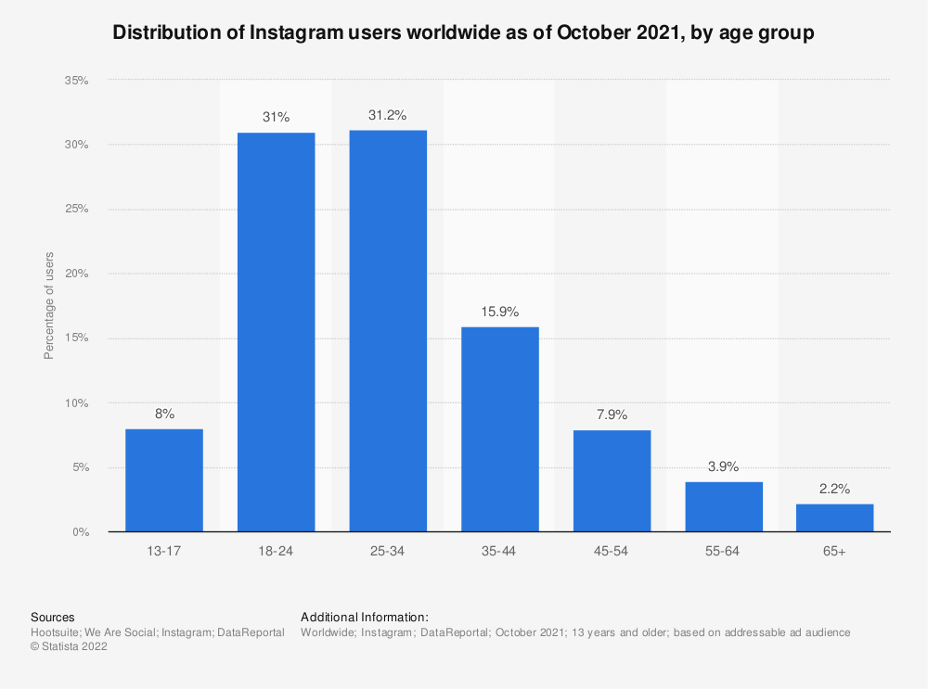

This means that the largest age group on Instagram is effectively the same, resulting in businesses being able to consider products for both age groups and still be able to make the same profit out of it.

Furthermore, when looking at the distribution of Instagram users by age *and* gender, it is important to note the trend where age demographics of older than 34 years of age, women tend to make up the majority of users, opening the market for businesses to advertise specific products to that age and gender group. Those under 34 years of age show a trend of a men with a larger percentage of the age groups population.

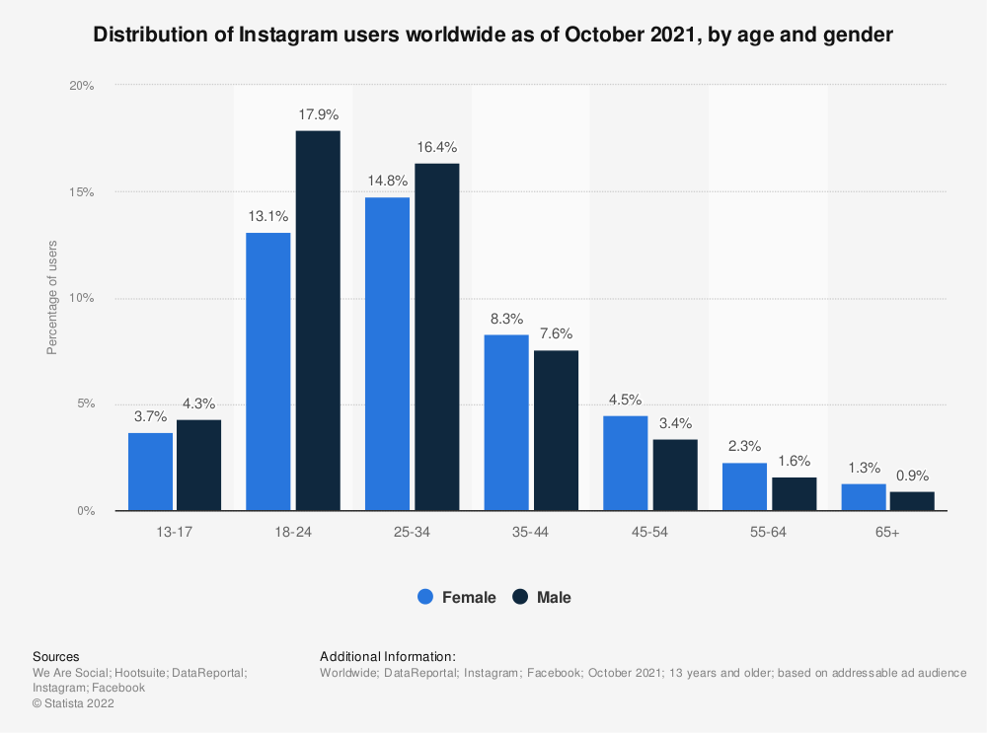

(Statista Research Department, 2022)

### Instagram and Business

Through the Instagram professional account, there are several benefits available. As companies can access the professional/business account section, they gain access to features such as page insights, scheduled posts, and much more. Since Instagram is primarily for photos and videos, this leads to Instagram’s photos/videos being highly optimised and therefore allowing businesses to take full advantage of Instagram’s different features. Furthermore, through uploading consistently potential customers can view old posts and clearly see several things, such as how the business treats their customers (through the comments), and whether the business has improved overtime.

Some of the features for Instagram and business include:

* Business page
* Page insights
* Improved biography
* Post scheduling
* Instagram shop
* Advertising
* Quick replies
* Approve brand content tags
* Links in stories
* Call to action

#### Business page

“Business page” or professional accounts on Instagram allow users into a multitude of features that otherwise would not be available to them. The users/businesses can access this through the settings section of the page, and from there switch their account to a business account as seen below.

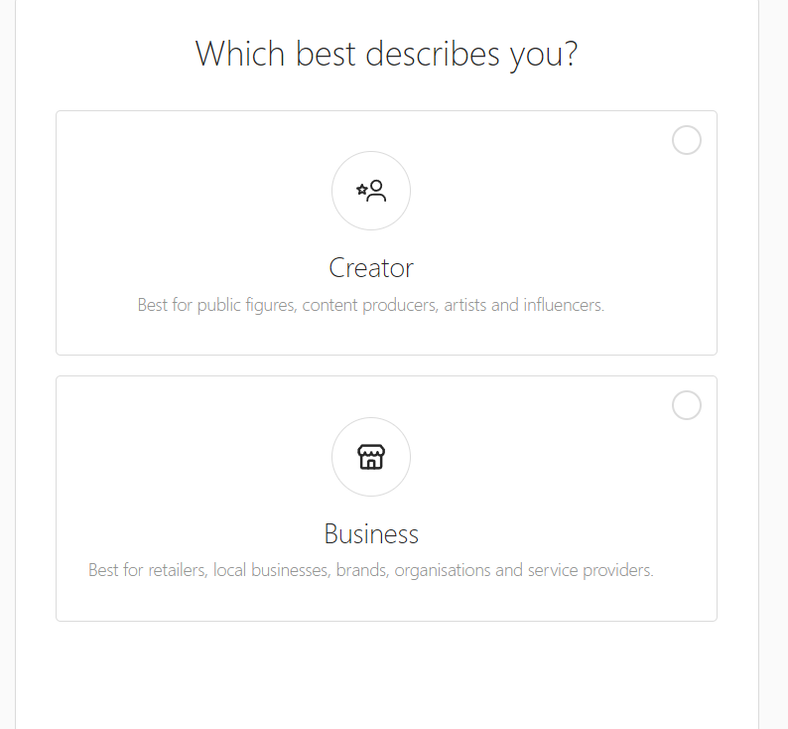

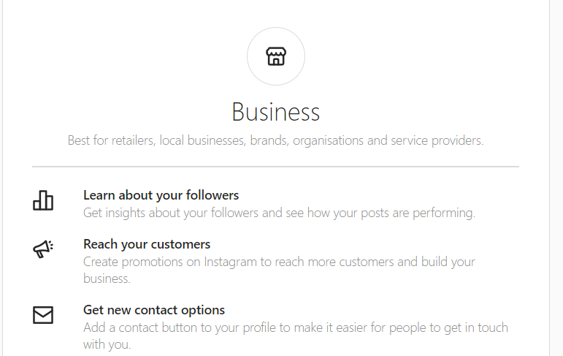

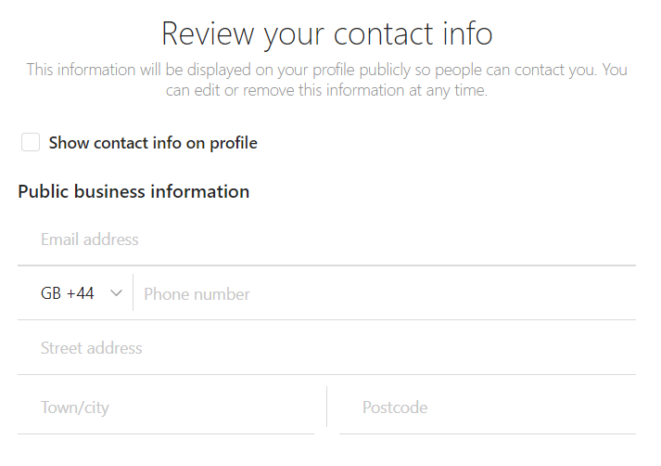

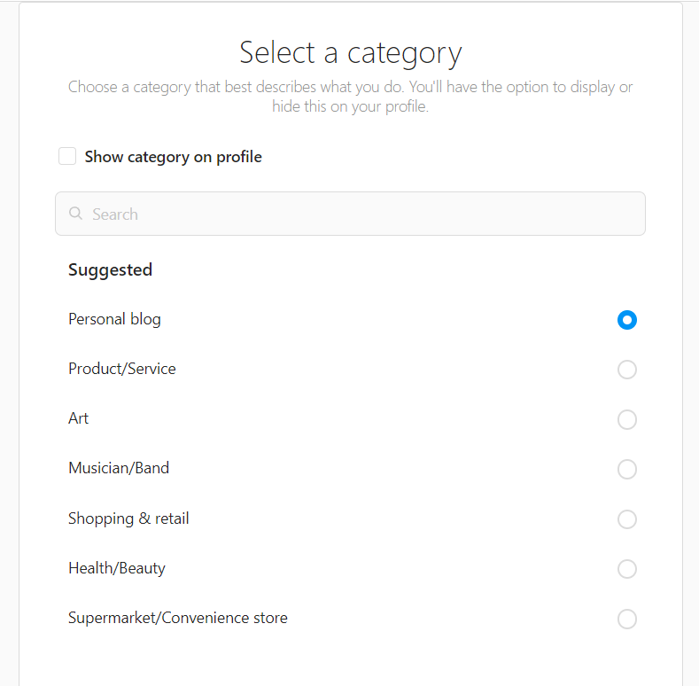

This allows a business to create a page dedicated for their products and brand, which can help establish a business on Instagram and create an online presence for them, much like Twitter for Professionals and Facebook pages.

This is an example of a business page.

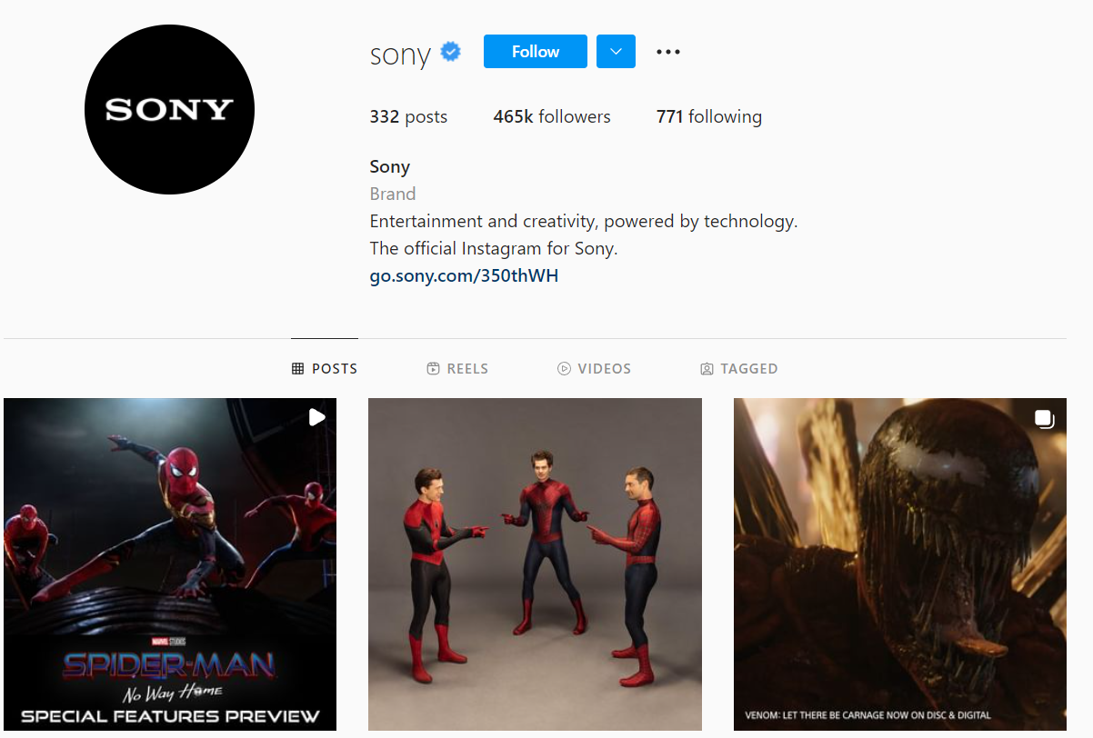

This is an effective example of a business page as it takes advantage of the features provided by a professional account and utilises the features available.

#### Page insights

Much like Facebook and Twitter, Instagram offers its own analytics/insights into a user’s business account.

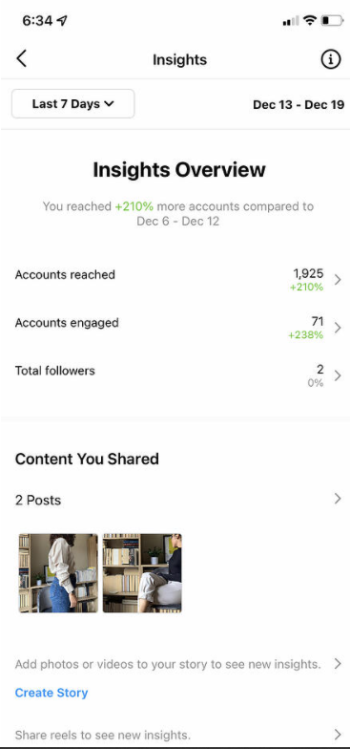

These insights are crucial for businesses as they allow business to develop their content and see what content they are posting is doing well and what is affecting the business negatively.

#### Improved biography

This feature of business in Instagram allows businesses to have an improved bio on their page. This allows businesses to add an identifying label if they decide to choose, such as “Brand”.

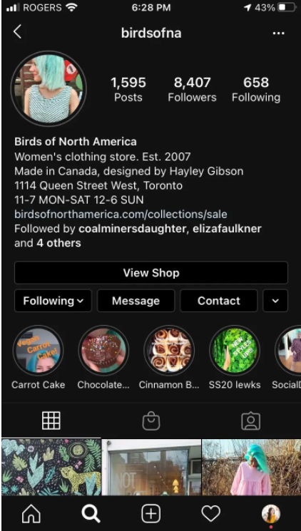

Business profiles are also allowed to add contact information, such as an email address, a phone number, and a business address to allow followers and potential customers to contact the business and call to action buttons.

This is an effective use of an improved biography as it has all the aforementioned features of an improved biography, optimising the business account as much as possible with the available features, and encouraging users with a positive and open business image.

#### Post scheduling

As seen above with Facebook and Twitter, this allows users to post content without having to personally do it.

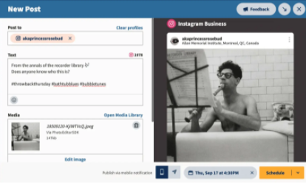

#### Instagram shop

Instagram shop is a feature available to business/professional accounts and enable the accounts to upload products and catalogues, tag goods, and in some situations even process transactions.



This is an important tool for businesses as it directly allows them to generate revenue and advertise their own products on their page, while linking it directly to posts to capture the customers attention.

As seen above in the screenshot, this is an effective use of the Instagram shop feature, as it directly generates revenue and advertises the products the account has to offer.

#### Advertising

Like Facebook and Twitter, Instagram offers the opportunity to advertise on the application through an Ad manager. Instagram Ads are created through Facebooks Ad manager, and therefore are made the exact same way as shown above, and therefore can be ran at the same time as the Facebook ads.

There are a few differences, such as the type of advert that the business wants or whether it wants a link associated with it, as shown below.

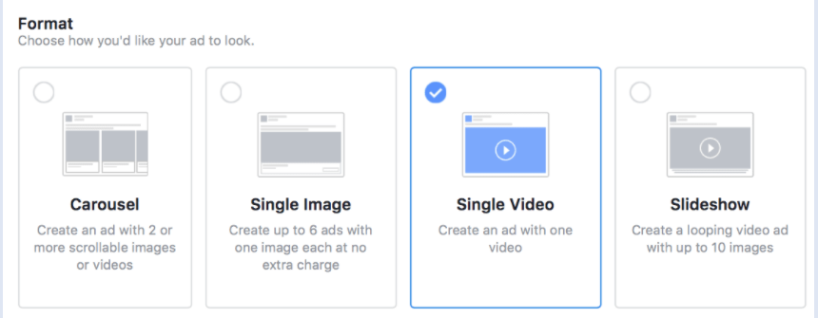

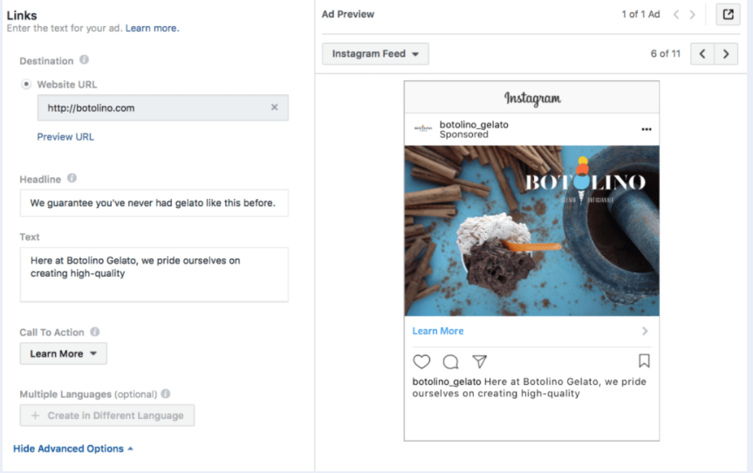

#### Quick replies

Quick replies are a feature available to professional accounts that allows businesses to set quick responses in the form of shortcuts, such as the screenshot shown below.

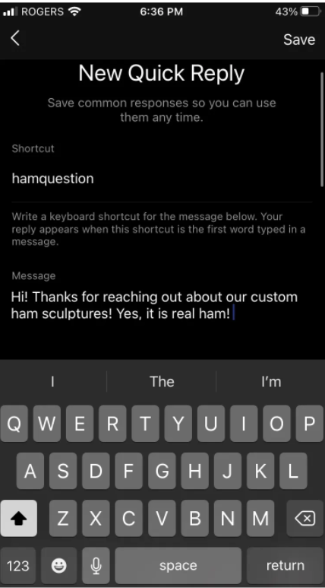

This allows businesses to standardise their responses to questions to ensure consistency and reduce the risk of interacting with customers online by potentially saying something which may cause issues. Furthermore, this also allows businesses to save time when responding to customer queries.

#### Approve brand content tags

Business accounts can restrict strangers from tagging the businesses accounts through “branded content”. This is important to businesses as it allows them to prevent false advertisements/endorsements and prevent strangers from using the businesses name negatively.

As seen below, this is a use of approved accounts by a business, which only allows a single account to tag them, which is an effective use of this feature, as it prevents all unknown accounts from mentioning the business which could negatively impact them.

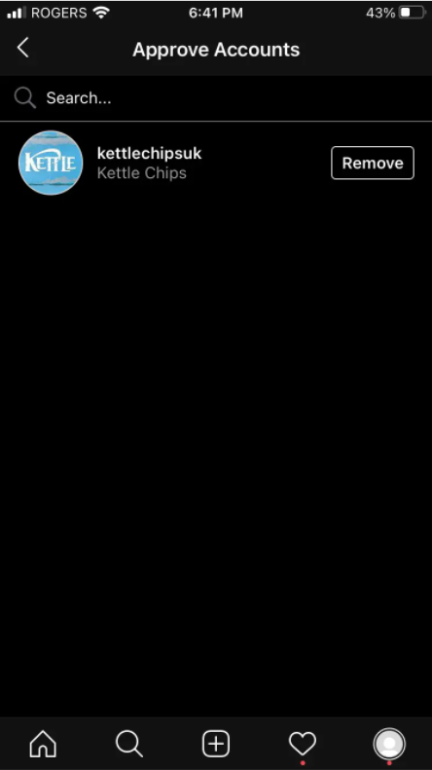

#### Links in stories

Business accounts with more than 10,000 followers gain access to the ability to use links through stories. Stories are a key feature of Instagram as it allows businesses to reach out and interact with customers with a different form of media.



This is a key feature for business as it allows businesses to advertise to the user through stories, a feature that shows up on user’s home page as soon as they open the app, and therefore have a high chance of interacting with it. This allows businesses to market their products through links and adds ease for the user to do so, and therefore have a higher chance of having a user buy a product.

This is a good example of links in stories as it shows to the user explicitly how to access the link (Swipe up for 10% off!!) and will go directly to the site with the discount code applied, encouraging the user to buy something to gain the benefit of the discount.

#### Call to interest

As seen with Twitter and Facebook.

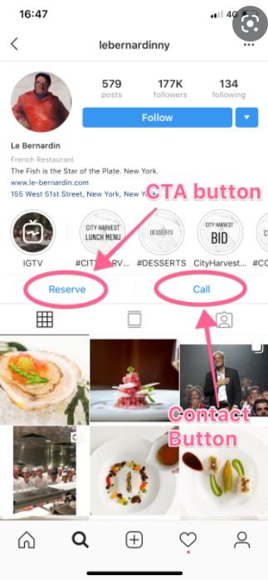

## Pinterest

Pinterest is another form of social media that is primarily used as a visual discovery engine for finding several things, like inspiration for art or recipes. Pinterest offers the option to save “pins” – or posts – which can be useful to come back to different pins later and revisit inspiration for projects. Pinterest is also split up through the “Home” page and the “Search” page, where users can view their pins that Pinterest thinks they will enjoy depending on their personalised activity, and search for specific tags in pins to find content they will enjoy respectively.

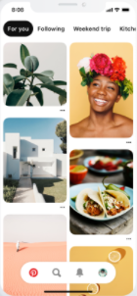

### Audience profile of Pinterest

The gender demographic of Pinterest is largely dominated by women, who make up 77.1% of the user base of Pinterest. This is vastly different from any other social media application, as generally men dominate the population, and even with that, the difference between men and women is never as much as this. Men make up 14.8% of the user base, and a further 8.4% are unspecified genders of the users, meaning these could be users that are non-binary or have non-conforming gender types.

Due to the nature of the application, the typical users of Pinterest will also tend to be those who are artistic or creative.

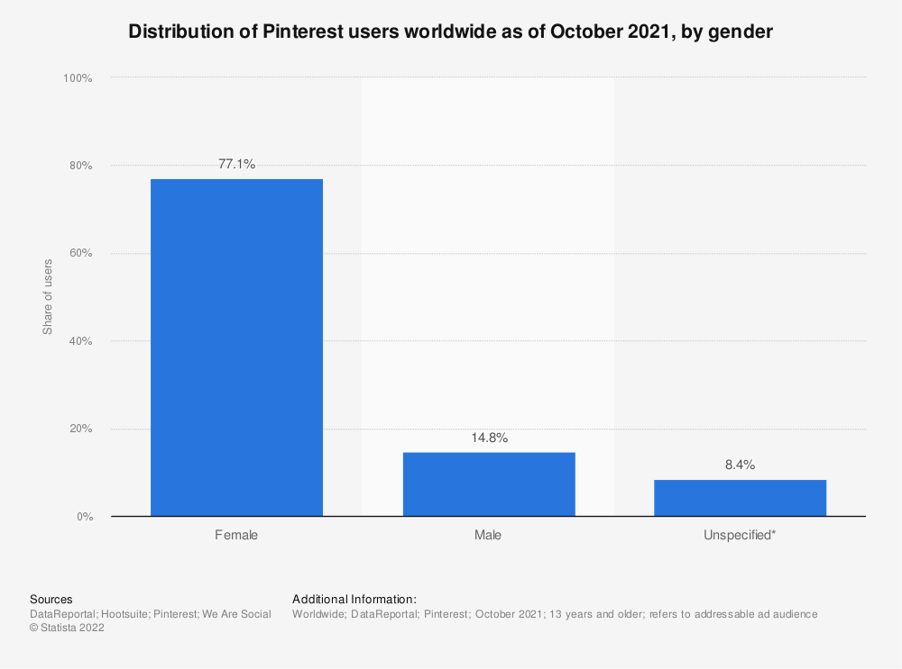

(Statista Research Department, 2022)

### Pinterest and Business

Although Pinterest slightly differs from other social medias in the way it is presented, as it is not the same typical social media format, however there are still several features available, starting with the Pinterest business account.

Here are some of the features in Pinterest for business:

* Business account
* Linking posts to sites
* Advertising
* Analytics
* Generating traffic to sites
* Growing awareness
* Call to action
* Post scheduling
* Pinterest shop

#### Business Account

Like any other social media so far, Pinterest presents the options to users and businesses to create a business specific Pinterest account. This further expands into allowing users post analytics and several other features.

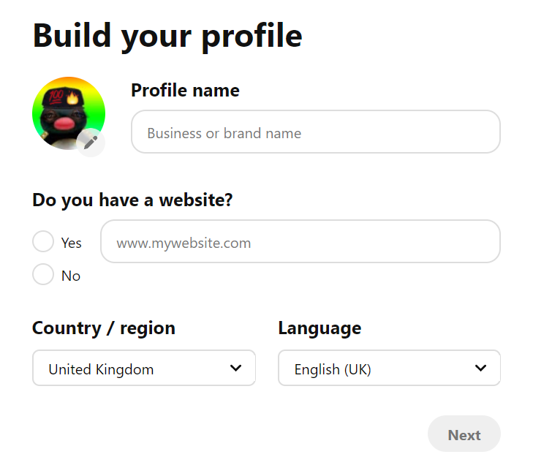

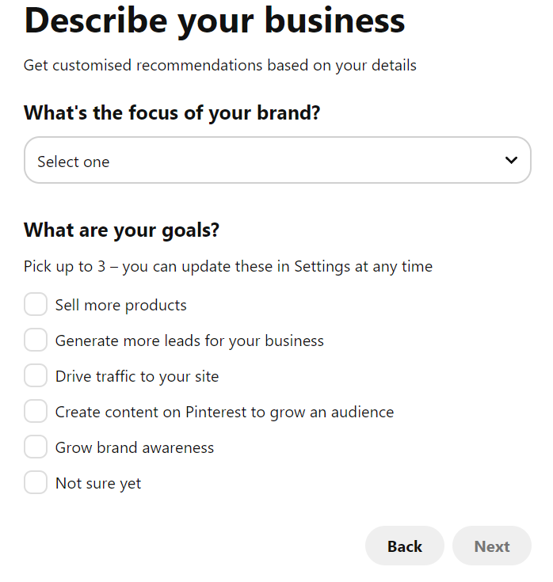

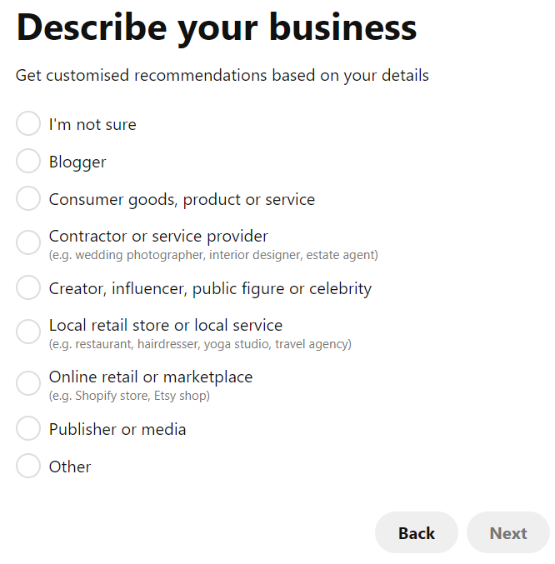

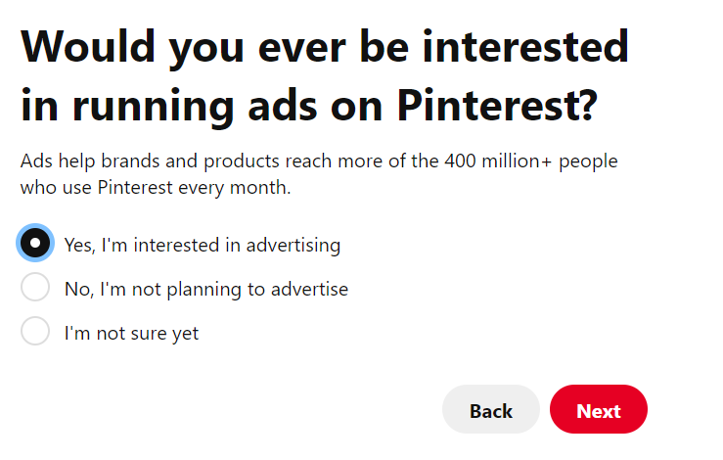

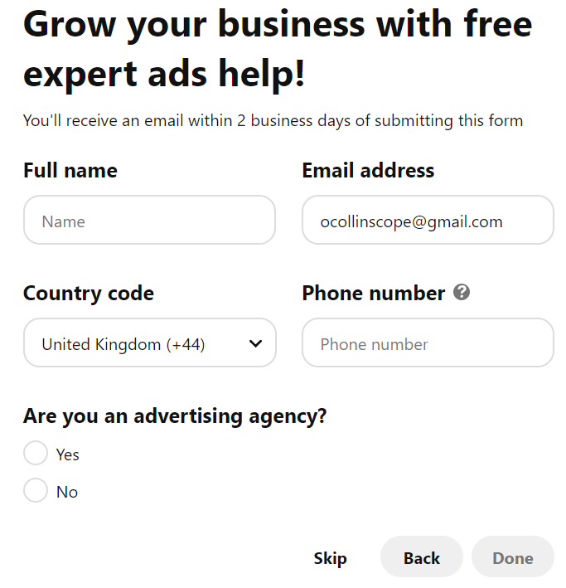

Like Facebook, Instagram and Twitter, the business account is crucial to businesses for them to grow, as it presents them additional options like advertising and analytics which could not ordinarily be used.

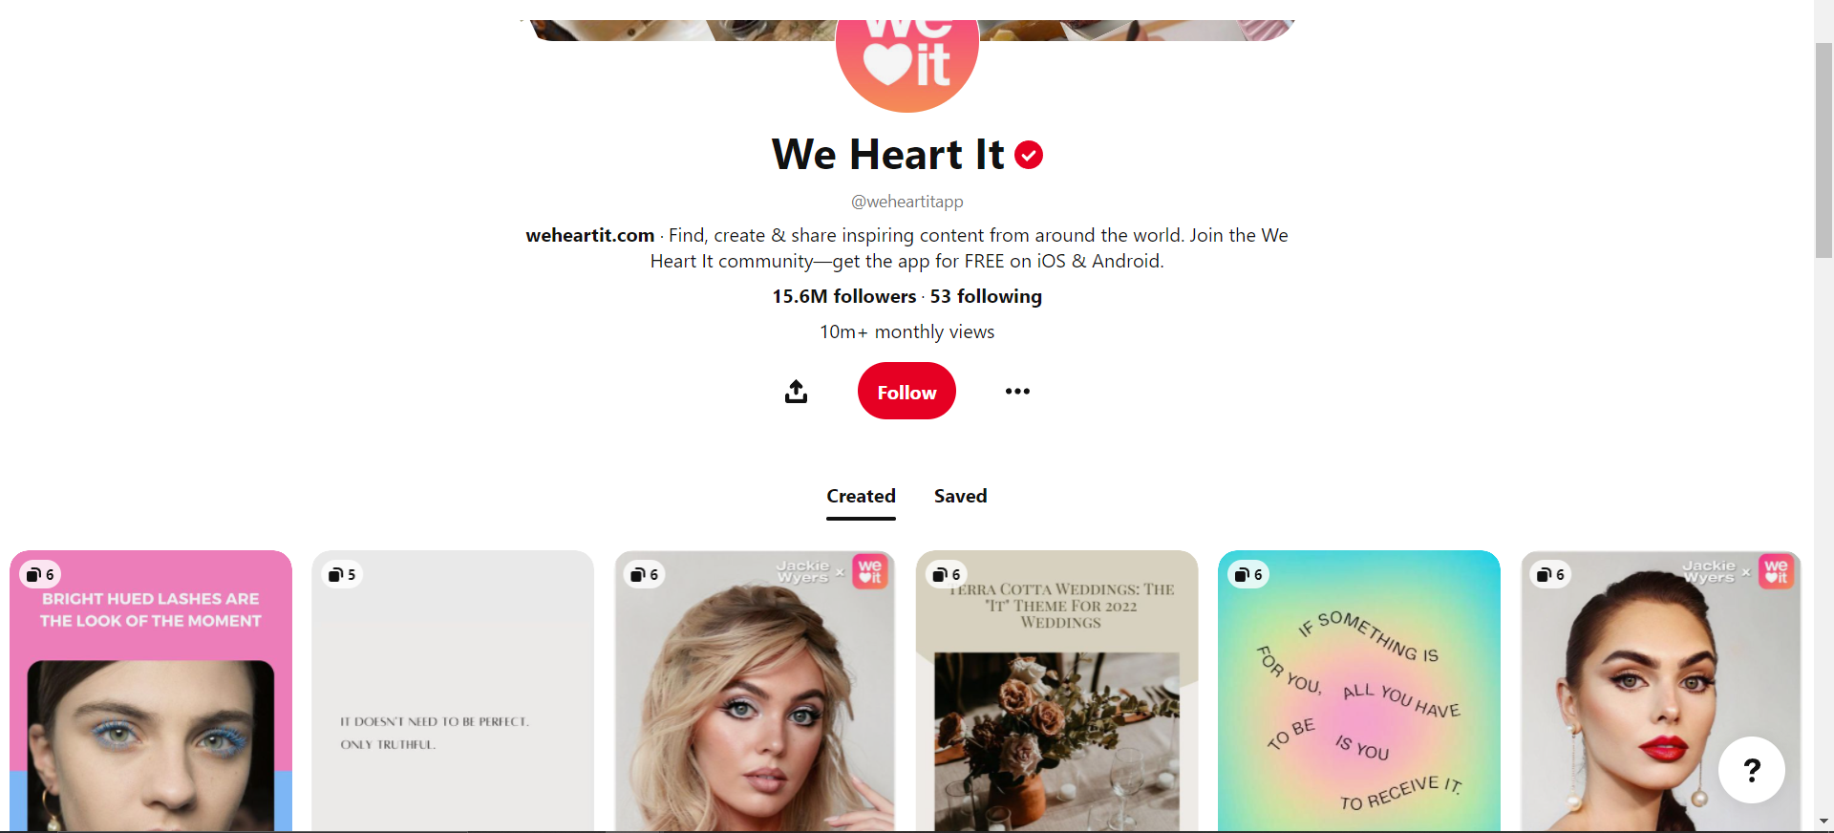

This is an example of a business using a Pinterest business account.

#### Linking posts to sites

Business Pinterest allows users to add links to their post which can be used to link a pin to a business’s website.

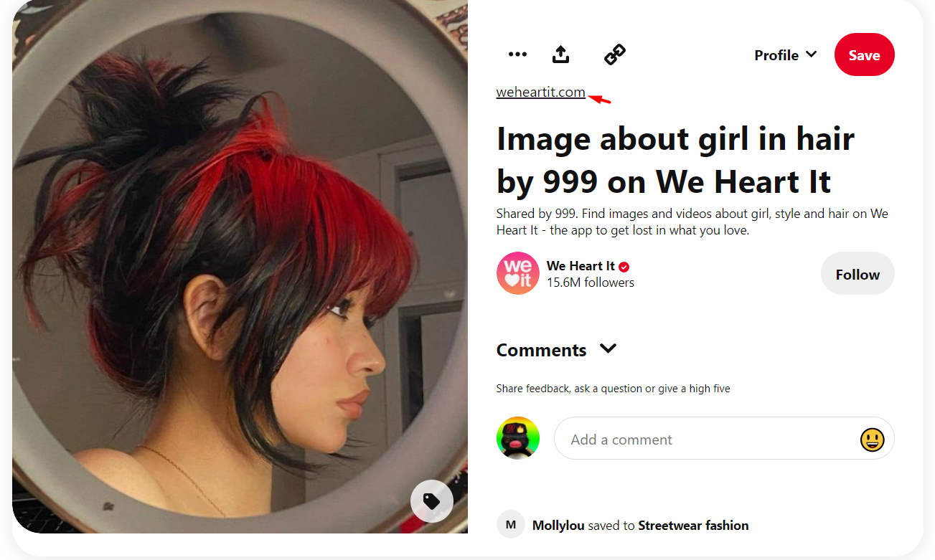

This is important as it allows businesses to generate site traffic to their website by giving users an easy way to visit their site, just by clicking a link, and could therefore lead to more purchases on their site or interactions.

This is a good example of a link, as it is relevant to the image, which is about beauty and the page/website/business is related to beauty. Furthermore, the link is short and easy to understand, so it can take users directly to the site without confusion.

#### Advertising

As seen above, Pinterest also presents the option to businesses to use advertising, just like the previous three social medias.

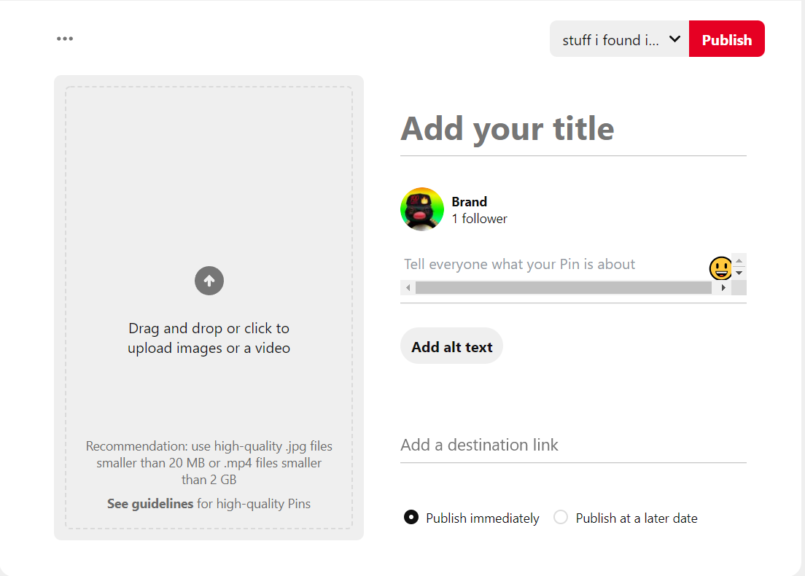

It allows businesses to upload a high-quality image or video, along with some text, and tags. It also allows the use of a link as seen above.

#### Analytics

Just like the previous three social medias, Pinterest offers analytics to its businesses.

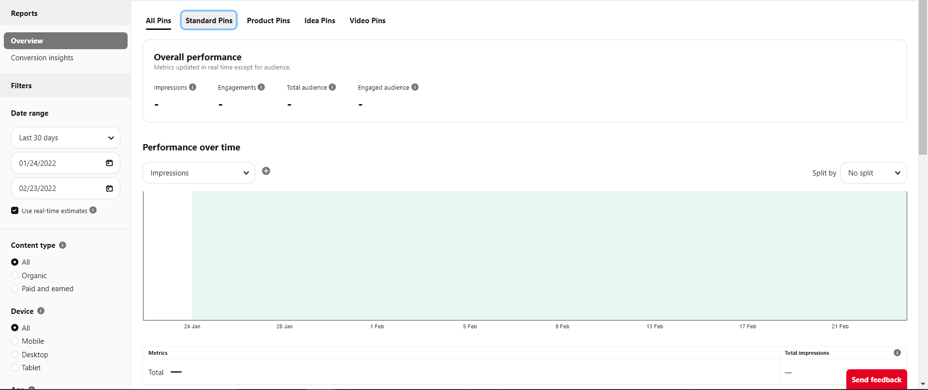

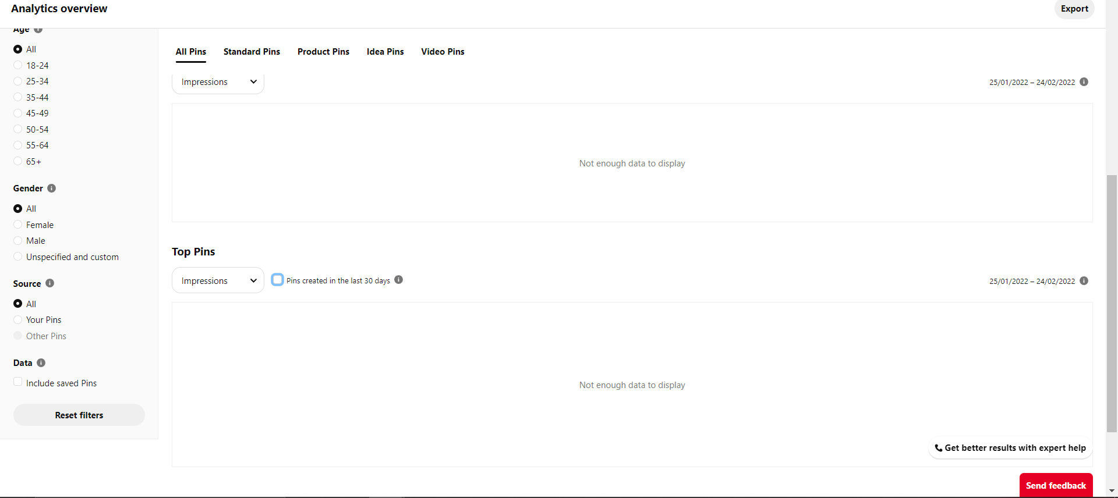

#### Generating traffic to sites

Through the use of links in posts and the biography where users can post their website domain, it is possible for business accounts on Pinterest to generate much more traffic to their site that would originally be possible.

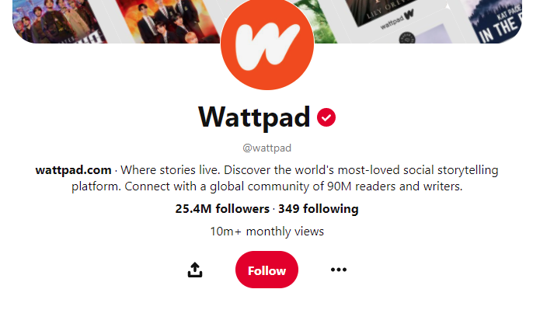

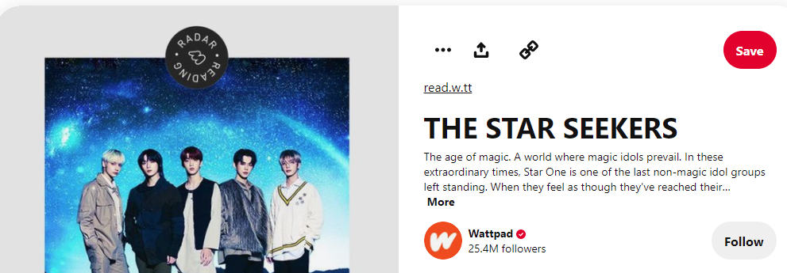

This is an important feature for businesses as it allows the to advertise their site, which closely links into advertisement and links in posts.

These are both good uses of this feature, as it clearly showcases the website domain name and links respectively, making it easy for users to go to the different sites and interact with the linked pages, boosting business interactivity.

#### Growing awareness

Similar to “Generating traffic to sites”, “Advertising”, and “Linking posts to sites” through the overall use of Pinterest and posting pins, businesses will find they are able to expand their userbase and customers. This can be achieved by businesses simply posting content relevant to their business, and eventually they will reach their desired users and grow as a business.

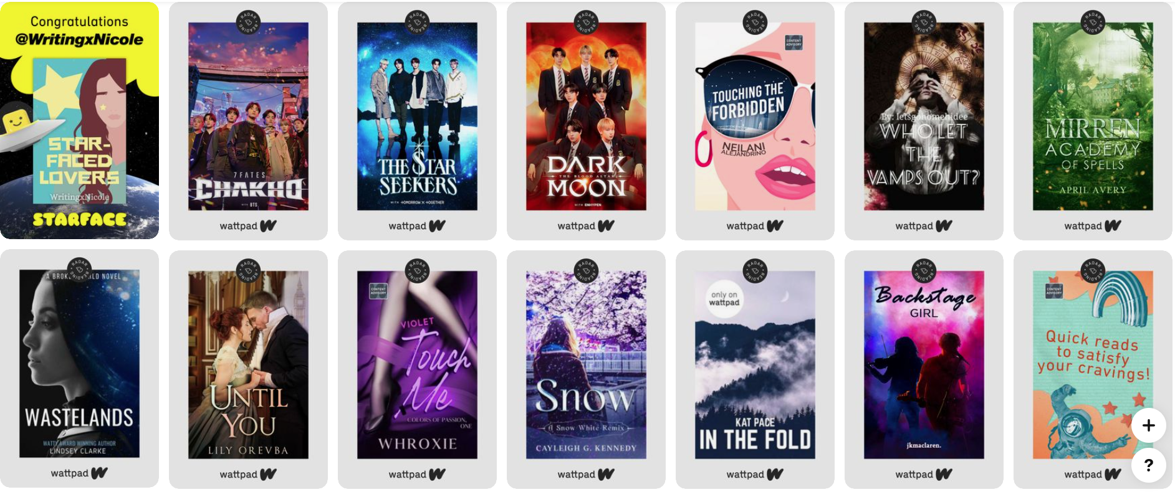

#### Call to action

As seen with the previous four social medias, Pinterest remains the same with its “call to action” features.

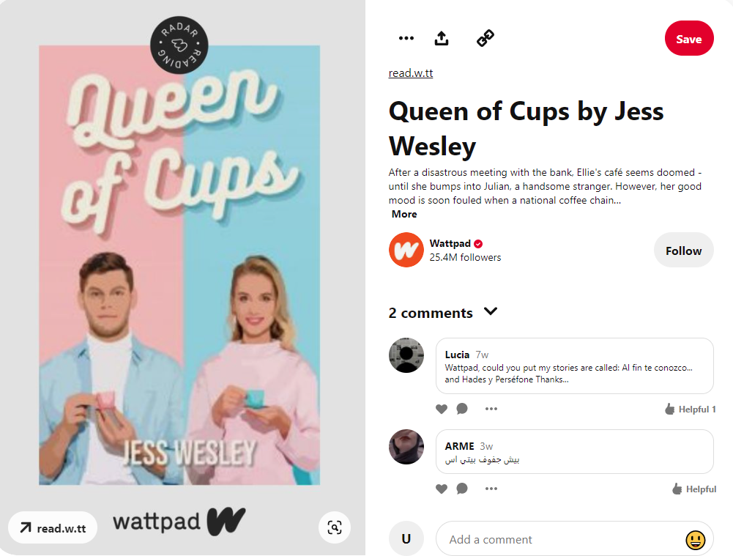

#### Pinterest shop

Much like the Instagram shop, the Pinterest shop allows Pinterest businesses to list their products and allows users to follow through links to the site to purchase specific products without having to search extensively.

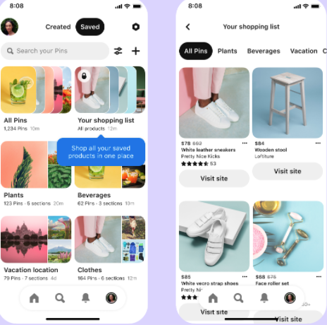

This is useful, just like the Instagram shop, as it allows businesses to directly post their products and give potential customers direct links to their site. Furthermore, depending on how the site has been created, it may also tell the business where a customer came from; this would show the business that their products on Pinterest are generating revenue and are beneficial – potentially indicating they should invest more.

#### Post scheduling

Just like the previous four social medias, post scheduling for Pinterest remains the same as others.



## YouTube

YouTube is the fifth and final social media I will be discussing. YouTube is a video sharing platform where content creators, such as businesses or the general population, are able to upload videos. These videos can be as long as the user wants, and due to the freedom of the site, users are generally able to upload anything they want, provided it is not graphic. In addition to this, YouTube has recently released a new feature called “shorts” which allows anyone with a camera and the YouTube app to post videos shorter than 60 seconds.

### Audience profile of YouTube

The audience profile of YouTube has a majority in the male population with 53.9% of YouTube users in the US being men. This means that the remaining 46.1% of users are female. Furthermore, an analysis of UK users on YouTube found that 24% of users were aged between 16-24 years of age, and the highest share of users being between 25-44 years of age with 44% of all UK users on YouTube. (Social Films, 2022)

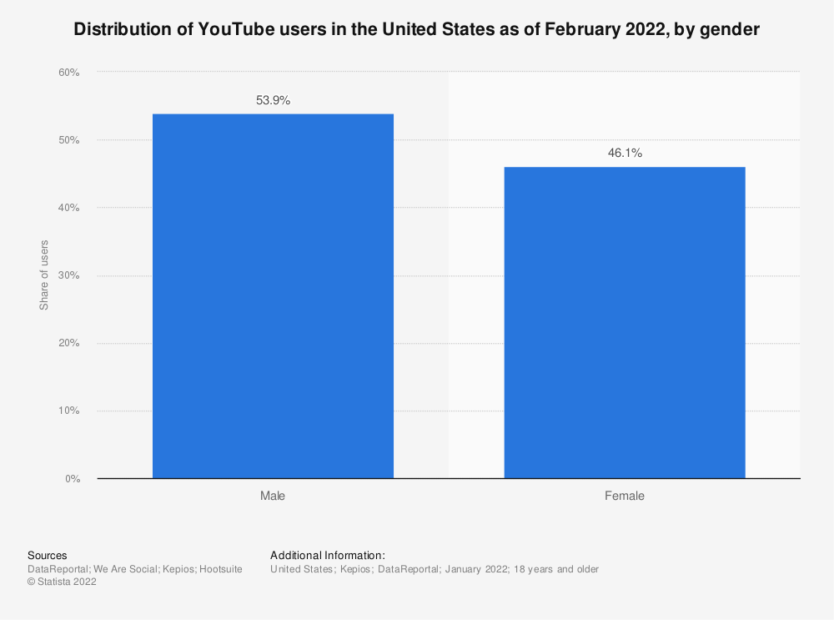

(Statista Research Department, 2022)

### YouTube and Business

There are several features of YouTube available for businesses to invest in, notably posting content, sponsoring established content creators, running targeted ads, and many more. YouTube is a crucial tool for any business looking to grow also due to its large reach and ability to interact with numerous audiences and multitude of cultures.

Some of the features include:

* Large number of YouTube users
* Marketing on YouTube/Google
* Reusable content
* Growing a worldwide audience
* Targeted Advertising
* Sponsoring creators
* Publishing videos
* Post scheduling
* Call to action

#### Large number of YouTube users

This refers to the fact that there is a plethora of users on YouTube that could potentially be customers on YouTube and therefore, YouTube is a necessity for any business to invest in as it allows them to expand their market and reach in order to maximise customer interaction and potential for profits.

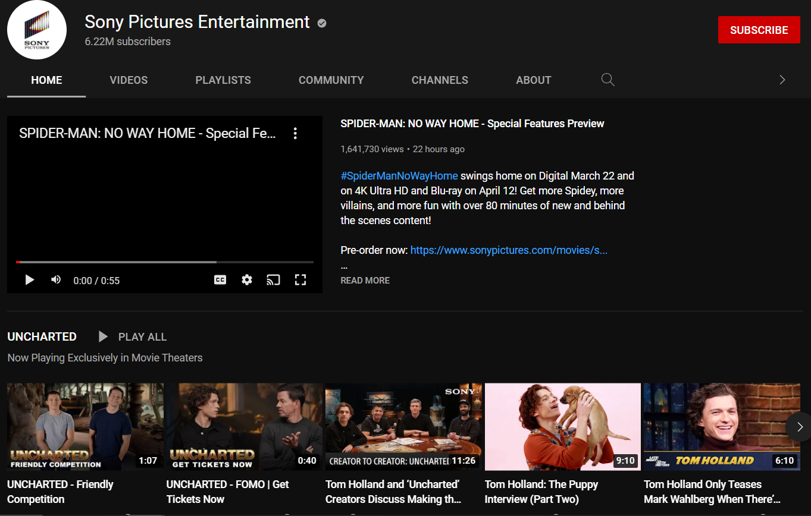

This is an example of how businesses can expand their reach on YouTube and the potential it has for millions of views.

#### Marketing on YouTube/Google

Through uploading videos and making a presence for the business on YouTube, businesses will find their page and YouTube channel appearing on searches, without having to advertise themselves there. 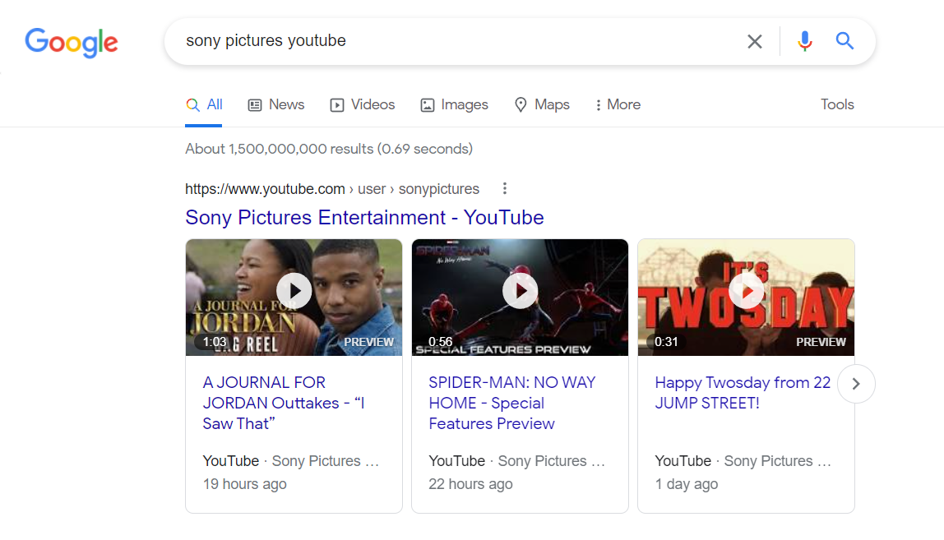  
This is important as it allows for businesses to promote themselves without having to pay and increase their reach to new customers.

#### Reusable content

Any content that a business makes can be translated into a new format/repurposed and therefore reduce the need to create new ideas which may take time, money, and resources that the company does not currently have on hand.

There are no explicit examples that I can find however it would be found all over YouTube, even repurposed and reused old videos can be reuploaded as if they were new to promote something for a business or simply just to maintain a presence.

#### Growing a worldwide audience

Arguably one of the most important features of a business is to have a large customer base that is not dependant on anyone or anything, and YouTube can be a great platform to do this. This is because YouTube videos can gain popularity in countries and regions that the business might not have originally thought of.

It can also be a stepping point for a business to realise that they have the ability to branch into other countries they might not have originally thought possible, due to the interactions with members of that country on their videos. 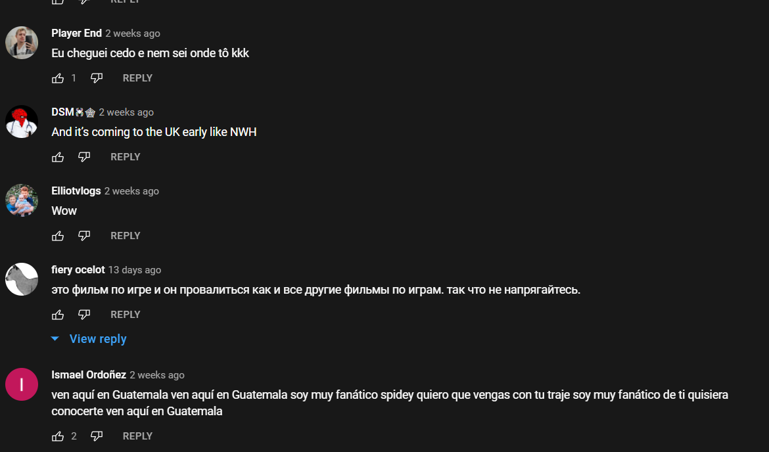

#### Targeted Advertising

Targeted advertising is as seen before with Facebook and Instagram, where businesses can target adverts at specific groups that they want to cater to.

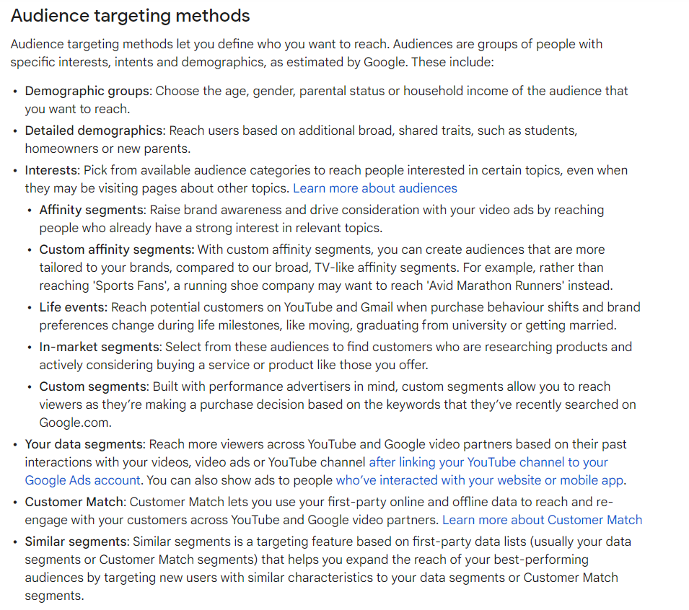

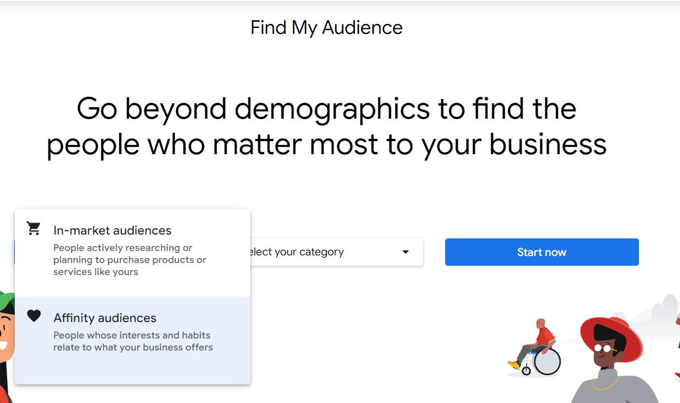

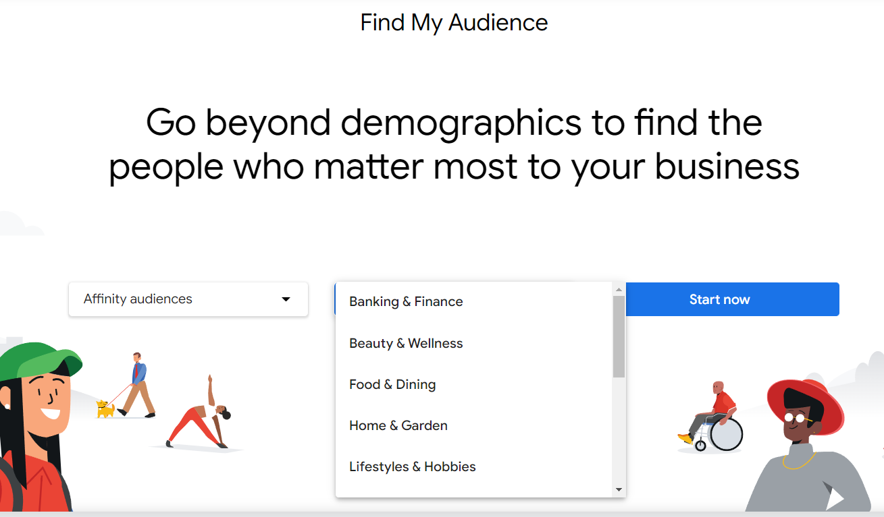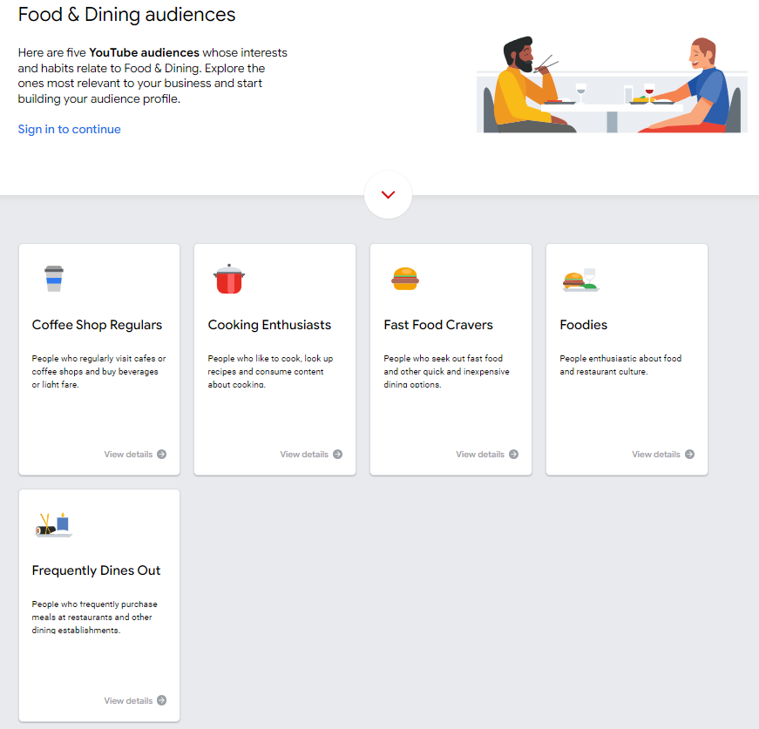

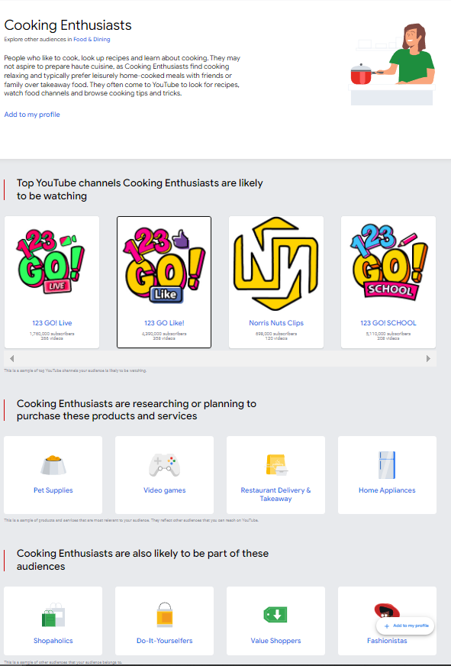

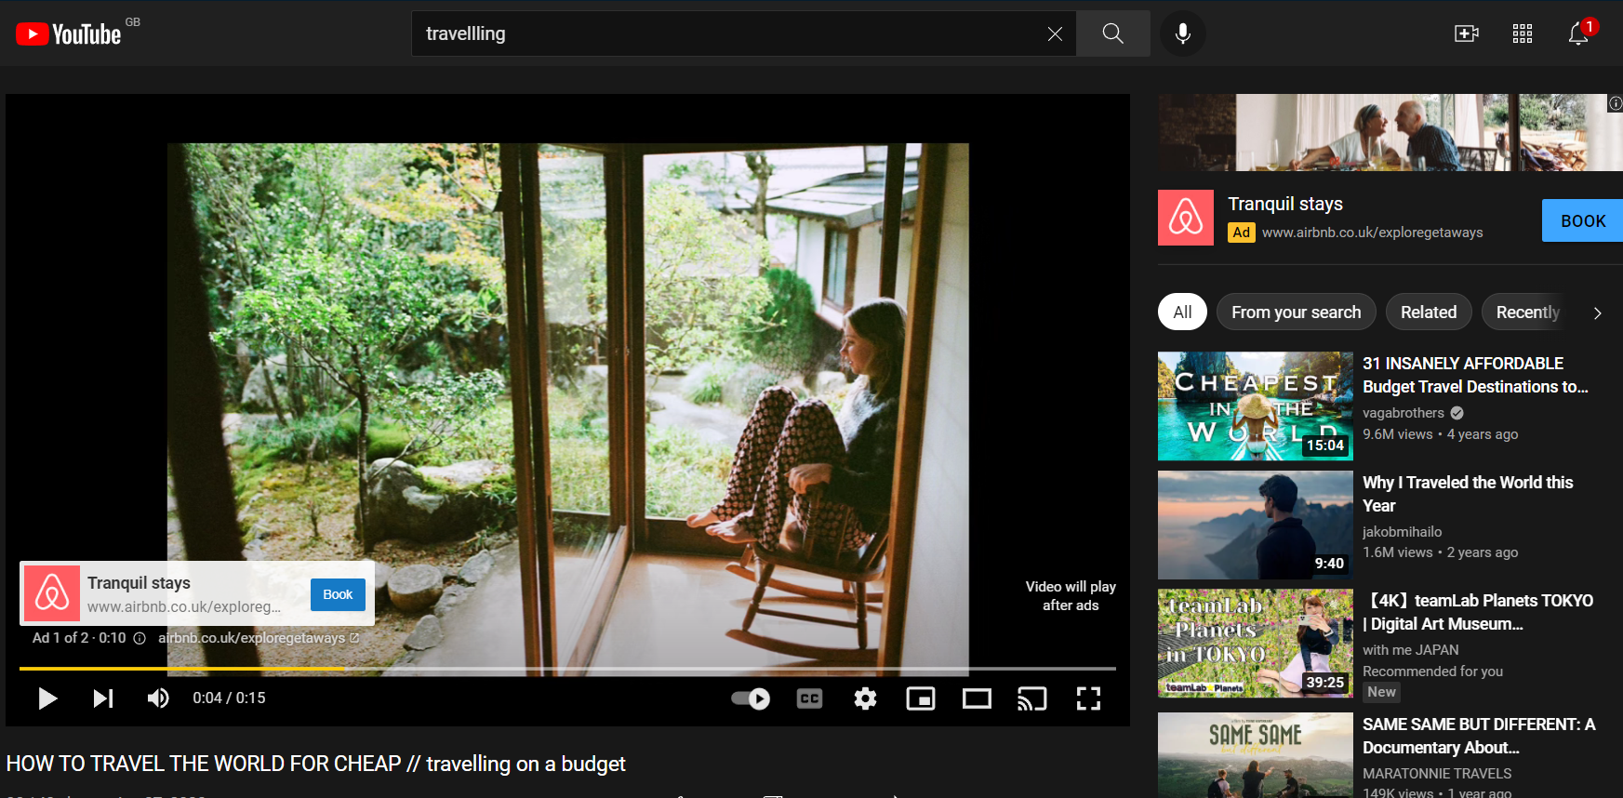

This is a good example as due to the fact I have searched up travelling, my targeted adverts are based on that. The business “Airbnb” has recognised that kind of search is good for them and their business and therefore use advertising on videos about it.

#### Publishing videos

Businesses will be able to publish videos and content that they create which will greatly benefit the business and allow them to engage with customers and viewers in more ways than just short clips, static images, and comments through posts.

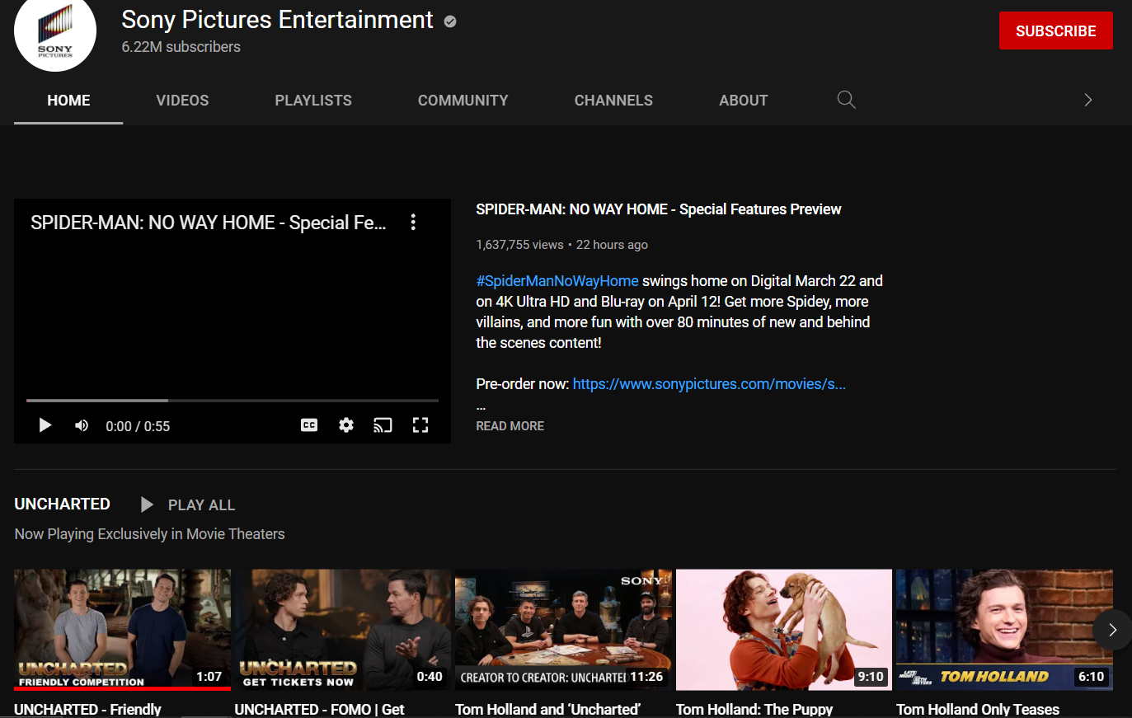

This example clearly shows how “Sony” takes advantage of this and posts multiple videos regularly to engage with customers and promote their own products.

#### Post scheduling

As seen with all the other social medias, YouTube can schedule their posts.

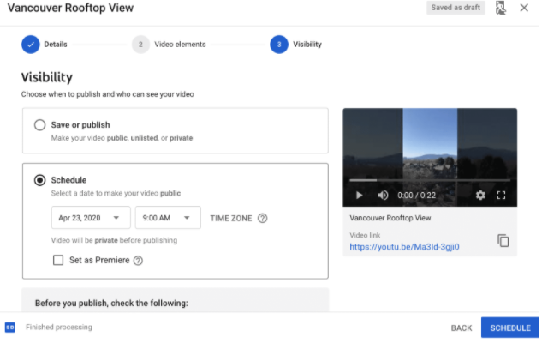

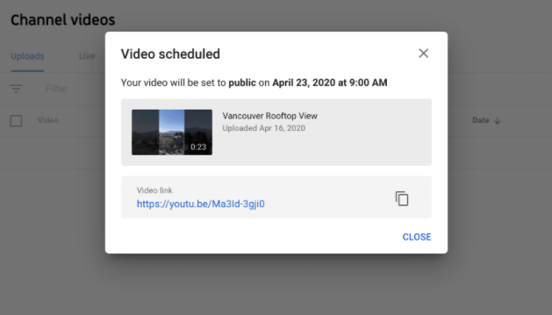

#### Call to action

Another feature which is the same as the previous four social medias.

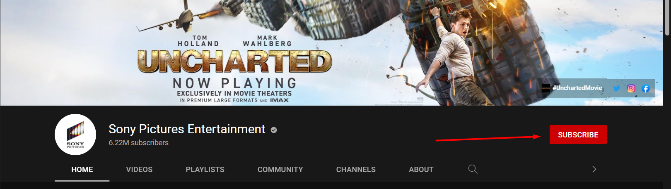

# Risks

There are several risks associated which can make it dangerous to post on social media. These risks include;

* Negative comments on social media sites and damage to reputation
* Time constraints on social media interaction, return on time investment
* Unforeseen consequences of posted content

## Negative comments on social media sites and damage to reputation

One risk of social media sites comes from user interactions with the business posted content. This can come in the form of hate on social media, publication of private interactions with the company painting them in a bad light, and negligence from the company in responding to comments and queries.

This can affect companies negatively because if these issues arise, then there may be damage to the reputation of the business, and therefore impact sales and user ratings/reviews.

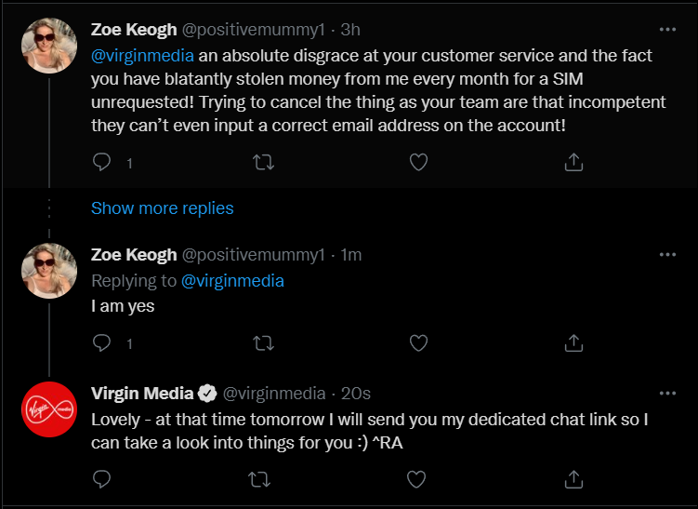

This is an example of negative comments and feedback which pushes the brand in a bad light, a risk of social media.

## Time constraints of social media interaction, return time on investment

Another risk of social media is that businesses will spend too much time on social media trying to push and promote their brand, only to not achieve results.

Social media, just like any other application involving posting content, does not always lead to success for the business and poster, and therefore is an investment that can reap no rewards. This means that the business can sink time, money, and resources into promoting their business and interacting with customers, without any return for their investment into this.

Furthermore, even if there is a return on the investment of social media, it may take far too long for the business, or be inadequate depending on how many resources were poured into it.

## Unforeseen consequences of posted content

This risk refers to issues that arise because of actions that the business did not assume any issues would come out of. Modern society, especially those on the internet, are very morally, ethically, and politically correct, and therefore business must ensure that their content is suitable and fits the standards of society. However, in some scenario’s issues may not be noticed by companies, and unforeseen consequences may come about because of the posts.

An example of this would be Adidas’s email regarding the “Boston Marathon” and congratulating people who “survived the Boston Marathon” in 2017. However, this was an issue because of the 2013 Boston Marathon bombings.

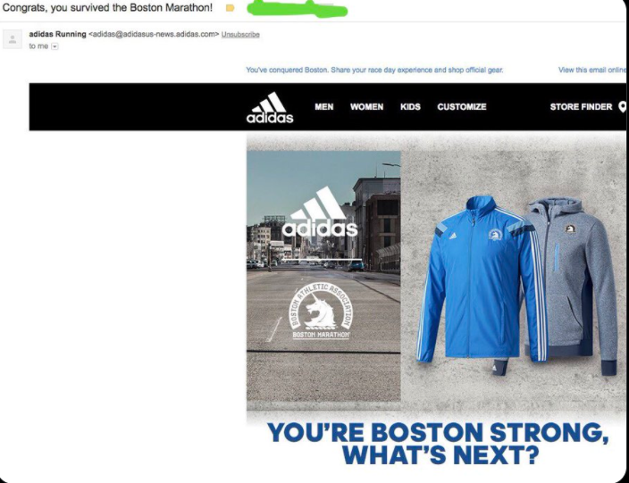

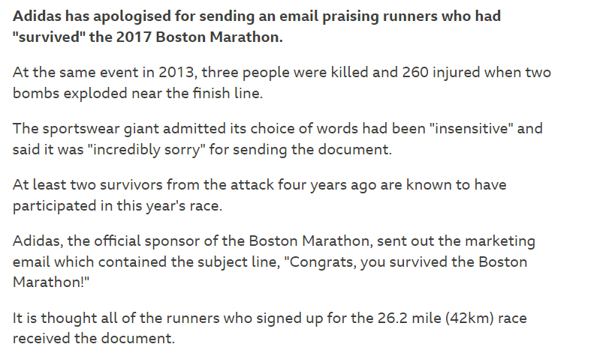

# Conclusion

In conclusion, social media is a necessary asset for businesses. It provides them with an opportunity to grow their business and new opportunities with advertisement and promotion. Furthermore, it gives businesses the options to communicate with customers and resolve issues without the need for formal communication which can take days, if not longer, and therefore proves itself as an effective tool for helping customers and promoting a good business image. While there are risks involved for businesses, the benefits and opportunities provided far outweigh the potential negatives. Overall, businesses should consider investing in social media and expanding their influence across the many different platforms available, especially with the numerous dedicated tools to support businesses on different applications.

# Bibliography

Aslam, S., 2022. *Omnicore.* [Online]   
Available at: https://www.omnicoreagency.com/facebook-statistics/#:~:text=56%25%20of%20the%20total%20Facebook,to%20only%20male%20or%20female).&text=(Source%3A%20Statista)-,The%20largest%20demographic%20group%20of%20Facebook%20users%20is%20between%20the,of%20the%20popul  
[Accessed 1 February 2022].

DataReportal, 2021. *DataReportal.* [Online]   
Available at: https://datareportal.com/essential-facebook-stats  
[Accessed 1 February 2022].

DataReportal, 2022. *DataReportal.* [Online]   
Available at: https://datareportal.com/social-media-users  
[Accessed 1 February 2022].

Howen, A., 2015. *Website magazine.* [Online]   
Available at: https://www.websitemagazine.com/blog/10-facebook-business-page-features-you-should-be-using  
[Accessed 2 February 2022].

Iqbal, M., 2022. *BusinessOfApps.* [Online]   
Available at: https://www.businessofapps.com/data/facebook-statistics/  
[Accessed 1 February 2022].

Kolowich, L., 2021. *Hubspot.* [Online]   
Available at: https://blog.hubspot.com/blog/tabid/6307/bid/28441/the-15-best-facebook-pages-you-ve-ever-seen.aspx  
[Accessed 8 February 2022].

Olafson, K., 2021. *Hootsuite.* [Online]   
Available at: https://blog.hootsuite.com/how-to-schedule-facebook-posts/  
[Accessed 8 February 2022].

Quadros, M., 2021. *Adespresso.* [Online]   
Available at: https://adespresso.com/blog/call-to-action-examples/  
[Accessed 8 February 2022].

Shuffield, J., 2019. *DavesComputerTips.* [Online]   
Available at: https://davescomputertips.com/how-to-turn-on-facebook-profanity-filter/  
[Accessed 8 February 2022].

Social Films, 2022. *Social Films.* [Online]   
Available at: https://www.socialfilms.co.uk/blog/youtube-uk-statistics#:~:text=An%20analysis%20of%20UK%20demographics,%2C%2077%25%20were%20YouTube%20users.  
[Accessed 24 February 2022].

Statista Research Department, 2022. *Statista.* [Online]   
Available at: https://www.statista.com/statistics/278414/number-of-worldwide-social-network-users/#:~:text=How%20many%20people%20use%20social,almost%204.41%20billion%20in%202025.  
[Accessed 1 February 2022].

Statista Research Department, 2022. *Statista.* [Online]   
Available at: https://www.statista.com/statistics/272014/global-social-networks-ranked-by-number-of-users/  
[Accessed 1 February 2022].

Statista Research Department, 2022. *Statista.* [Online]   
Available at: https://www.statista.com/statistics/398136/us-facebook-user-age-groups/  
[Accessed 1 February 2022].

Urrutia, K., 2015. *Single Grain.* [Online]   
Available at: https://www.singlegrain.com/facebook/12-important-facebook-features-every-marketer-needs-to-take-advantage-of/  
[Accessed 2 February 2022].

Urrutia, K., 2022. *VoyMedia.* [Online]   
Available at: https://voymedia.com/how-to-block-words-and-profanity-from-your-facebook-page/  
[Accessed 8 February 2022].